

Faculty of Science and Engineering

School of Computing and Information Science

**Module MOD002589:**

**Database Design and Implementation**

**Element 010**

**Portfolio**

**SID NUMBER: 2218952**

Trimester 1 – 2023

Submission deadline: 08/12/2023

**Table of Contents**

**Requirement Analysis** 3

**Description of the three websites chosen** 3

**https://www.nike.com/gb/** 3

**https://www.adidas.co.uk/** 4

**https://uk.puma.com/uk/en** 4

**List of data fields** 4

**List of data fields from Nike** 5

**List of data fields from Adidas** 22

**List of data fields from Puma** 35

**Generic List** 42

**Design** 43

**Entity Relationship Diagram** 43

**Extended Entity Relationship Diagram** 44

**Normalised Model** 45

**Database Scheme** 46

**Implementation** 54

**Testing** 72

**Query 1** 72

**Business purpose of the query** 72

**Query in natural language** 72

**SQL Code and output** 72

**Explanation of the query’s output** 73

**Query 2** 74

**Business purpose of the query** 74

**Query in natural language** 74

**SQL Code and output** 74

**Explanation of the query’s output** 75

**Query 3** 76

**Business purpose of the query** 76

**Query in natural language** 76

**SQL Code and output** 76

**Explanation of the query’s output** 77

**Query 4** 78

**Business purpose of the query** 78

**Query in natural language** 78

**SQL Code and output** 78

**Explanation of the query’s output** 79

**Query 5** 80

**Business purpose of the query** 80

**Query in natural language** 80

**SQL Code and output** 80

**Explanation of the query’s output** 81

**References** 81

# **Requirement Analysis**

## **Description of the three websites chosen**

Each of the sites I chose are e-commerce sites. This means that all three sites provide the function of purchasing and ordering products. Additionally, all three sites are in the same area and sell shoes and clothing. In the screenshots you will only see products such as sneakers. I did this for the convenience of comparing sites.

### [**https://www.nike.com/gb/**](https://www.nike.com/gb/)

Nike is one of the most famous brands in the world. It is one of the biggest manufacturers of athletic sneakers and clothing in the world as well as a significant producer of sporting goods. (Nike Company, n.d)

### [**https://www.adidas.co.uk/**](https://www.adidas.co.uk/)

Adidas is a German corporation of clothes and sport accessories. It was the biggest sportswear producer in Europe and the second biggest worldwide producer in the beginning of the twenty-first century. (Lewis, R, 2023)

### [**https://uk.puma.com/uk/en**](https://uk.puma.com/uk/en)

Puma is a company that designs and markets sneakers, apparel and accessories, as well as other sports products. Puma products are sold all over the world. (GlobalData, 2023)

## **List of data fields**

In this section, I will provide the entities and attributes of each website's interactive pages. For each entity, a screenshot will be provided so you can see where the data was taken from. This way you will see where I found the entities and attributes for my generic list. Each website will have a slightly different list of entities and attributes, however most of them will look similar since all sites sell sportswear and sneakers.

For convenience, I made entity tables for each website. Each table has its own colour. I've coloured them in to see the similarities and differences between the sites. Thus, it will make it easier to create a generic list.

### **List of data fields from Nike**

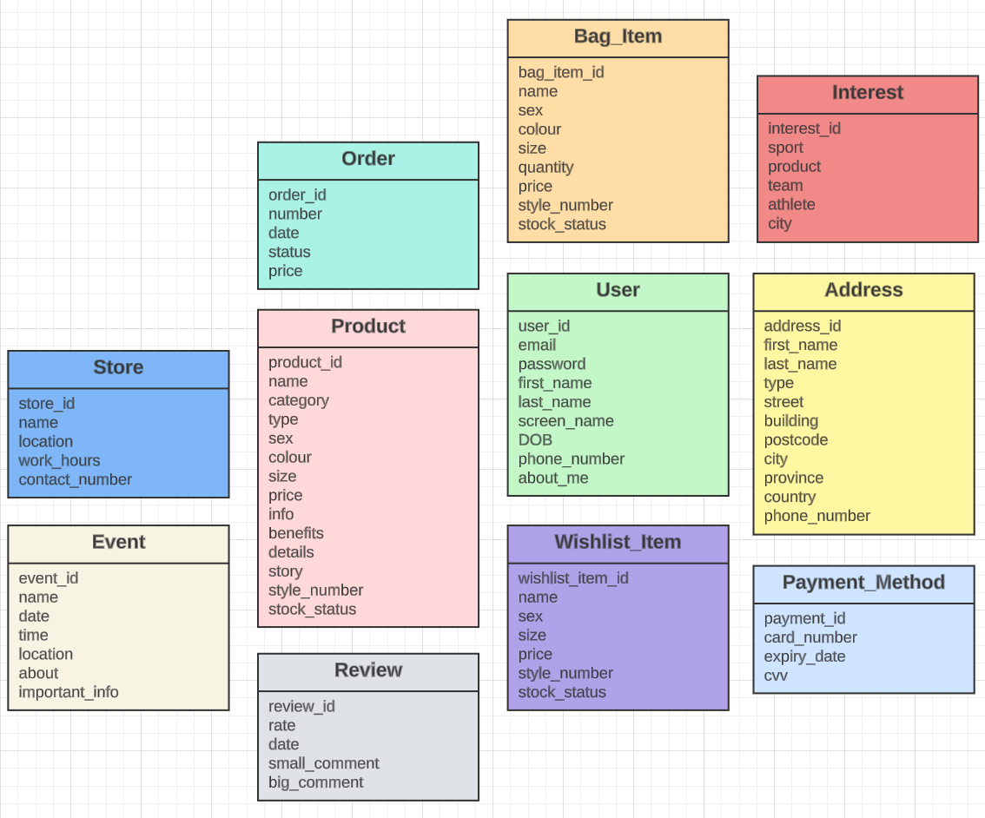

All screenshots that are shown for this site were taken from Nike website. (Nike, 2023)

**User:**

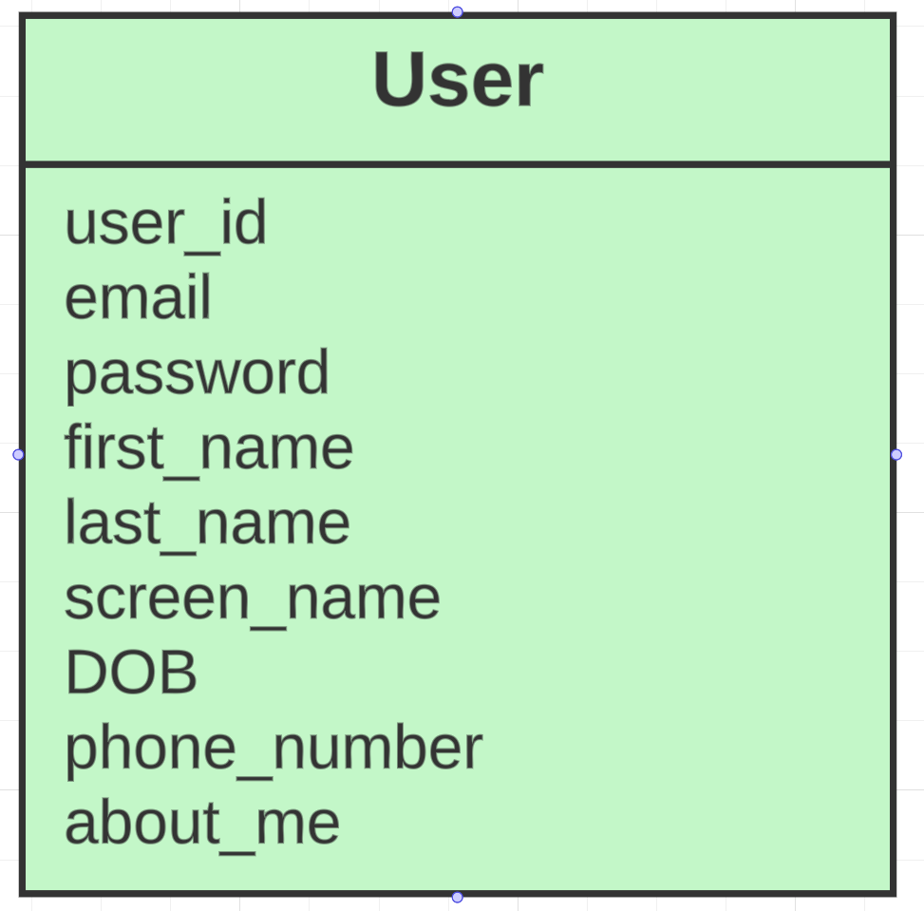

When registering, the user enters the following data: email, password, first name, last name, date of birth.

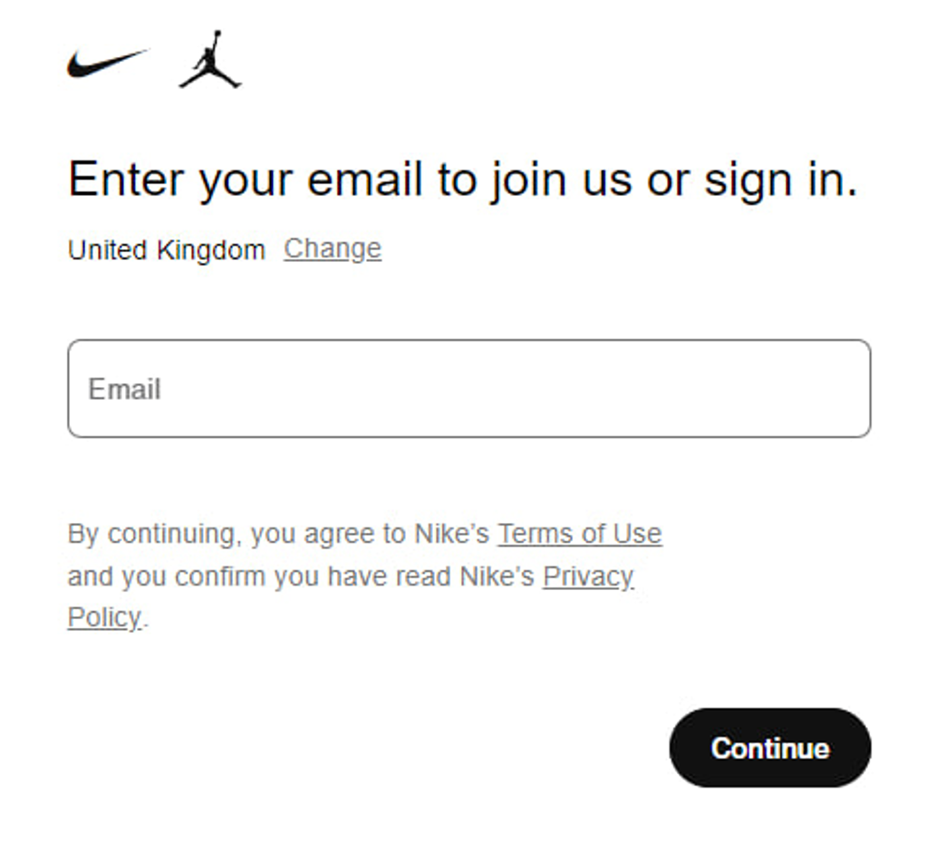

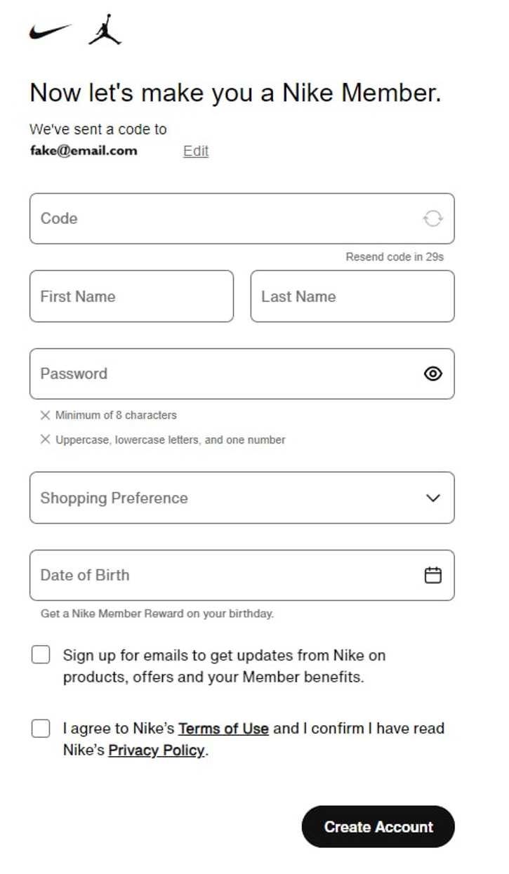

After a user registered he can add more data in account settings. He can add his screen name and phone number. Also, he can fill the “About Me” field. I did not include the “Hometown” field, because in the future the user will add his address and it will be stored in the “Address” entity.

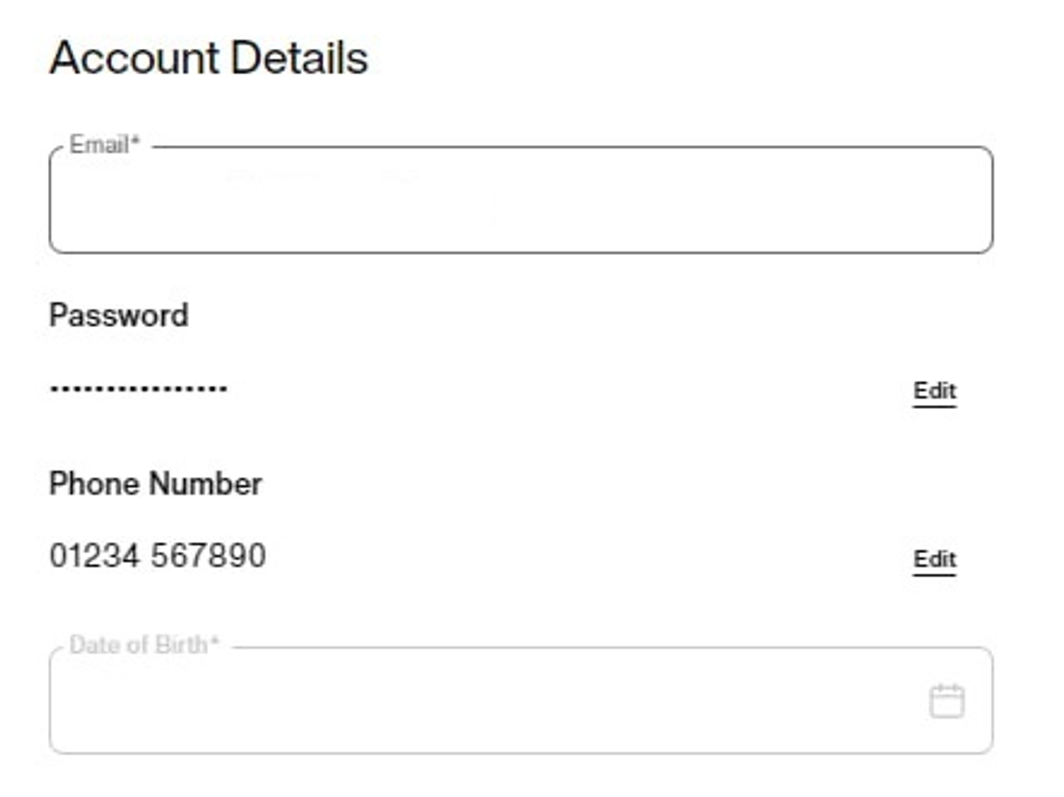

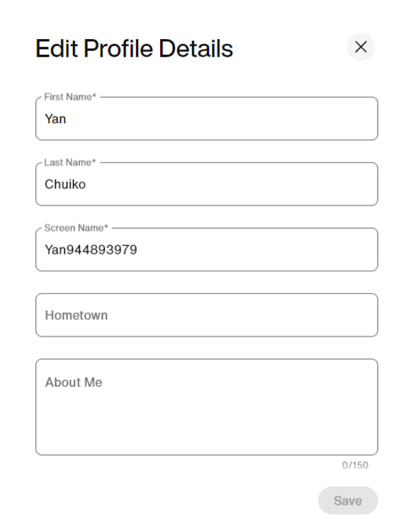

**Address:**

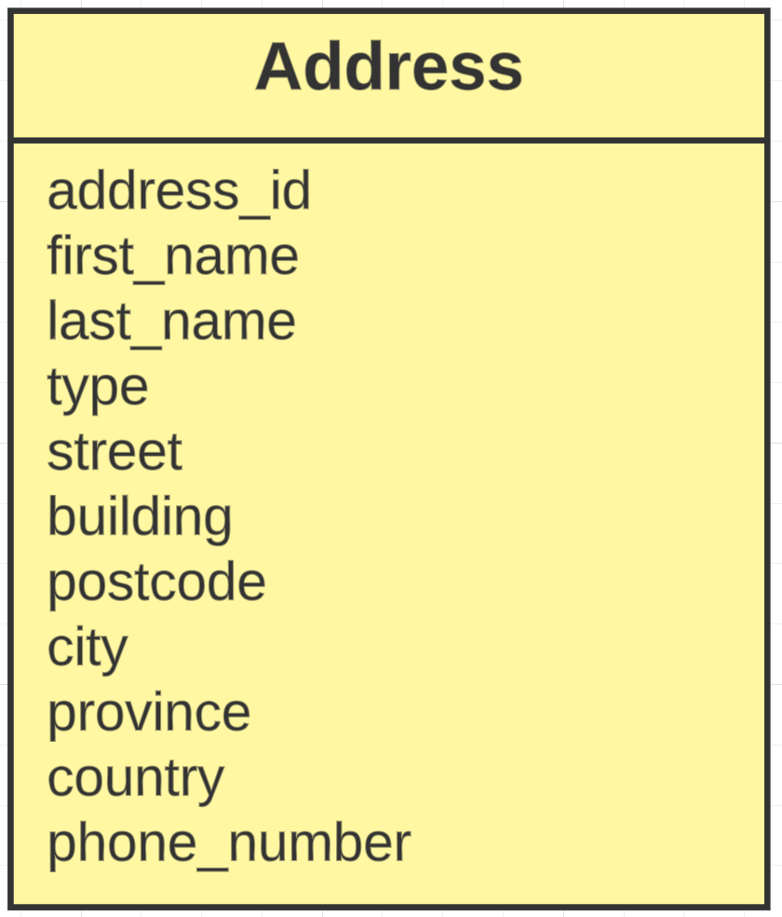

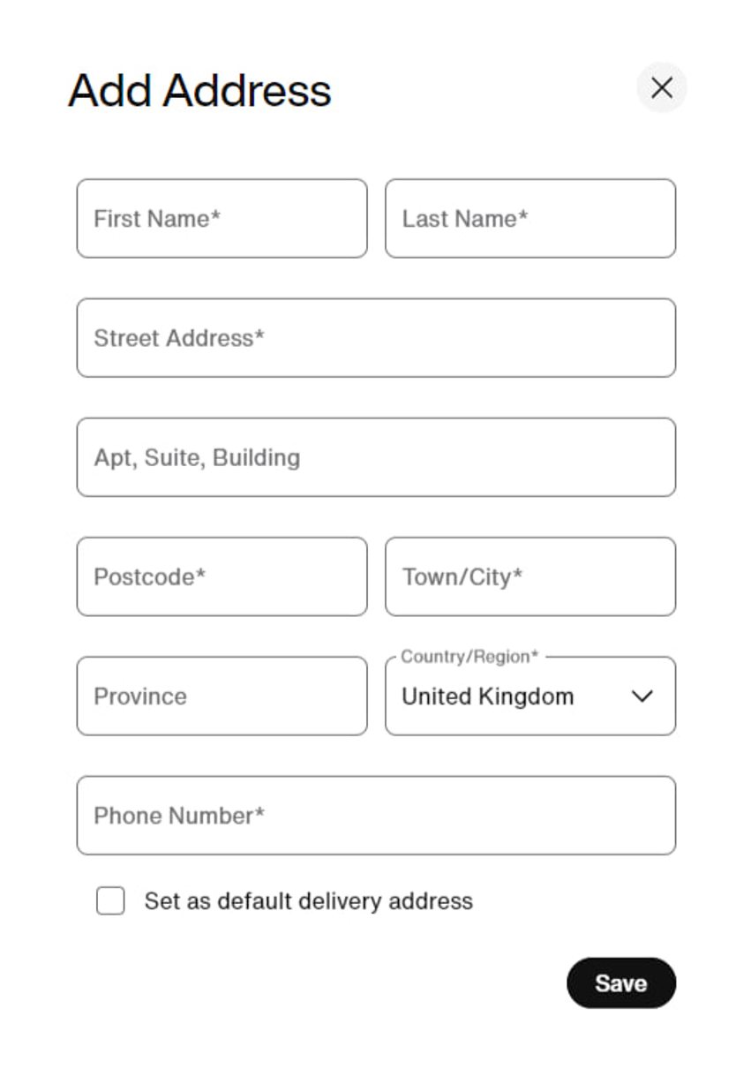

**Payment Method:**

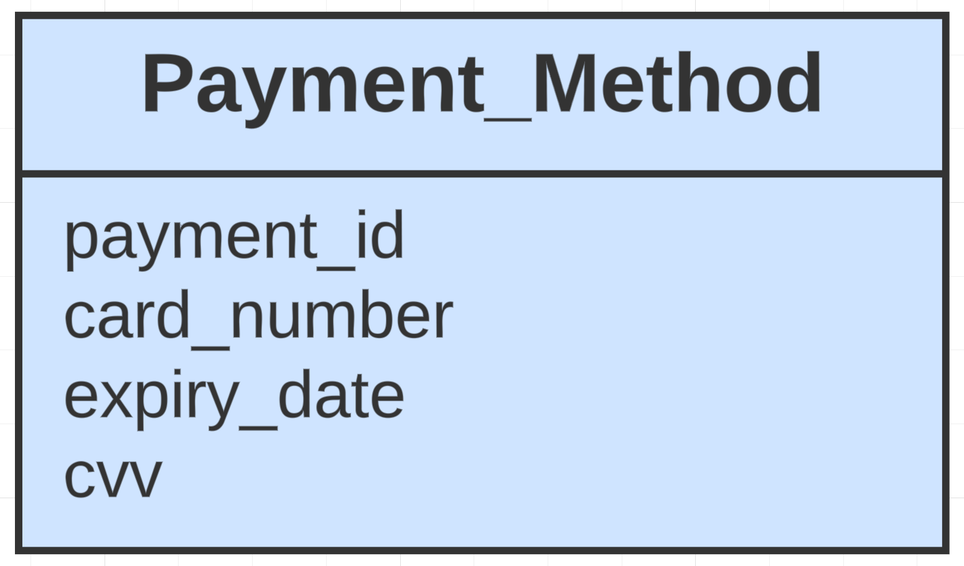

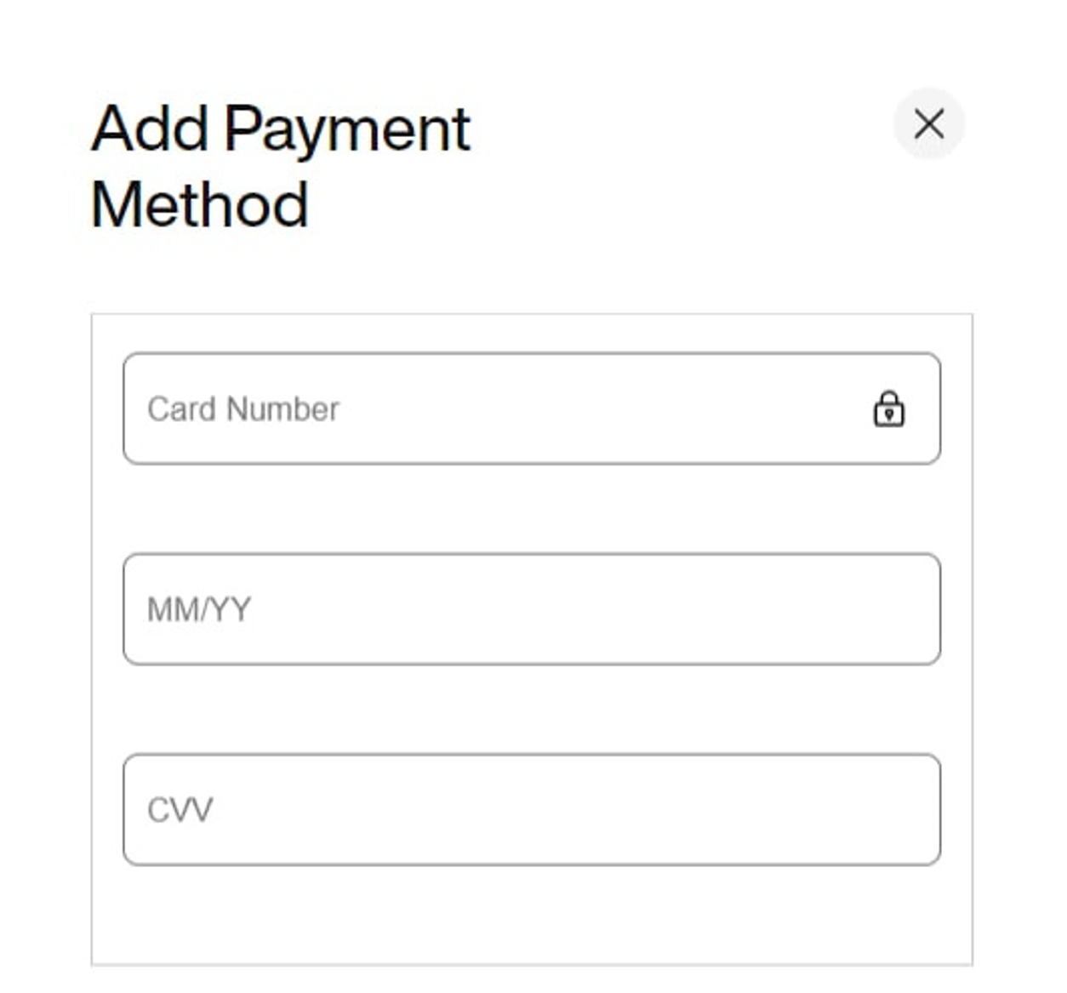

**Bag Item:**

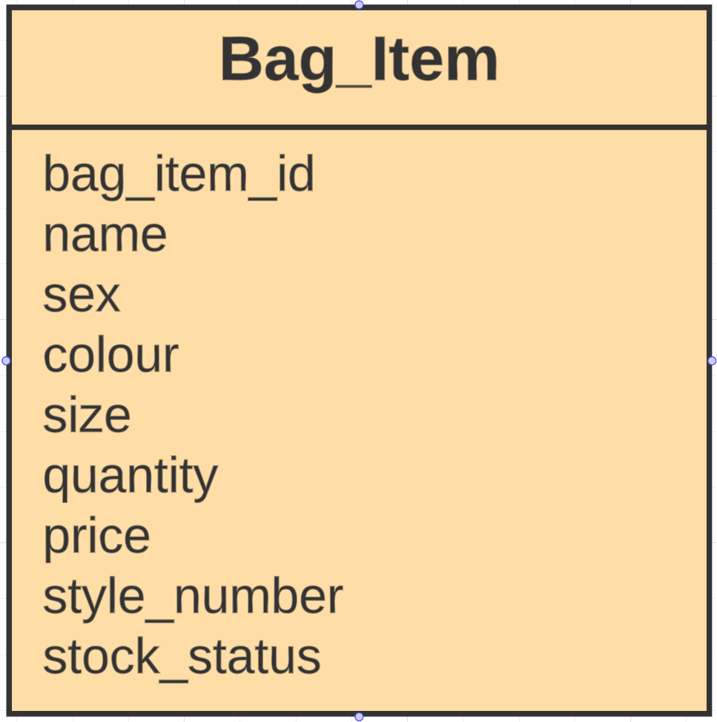

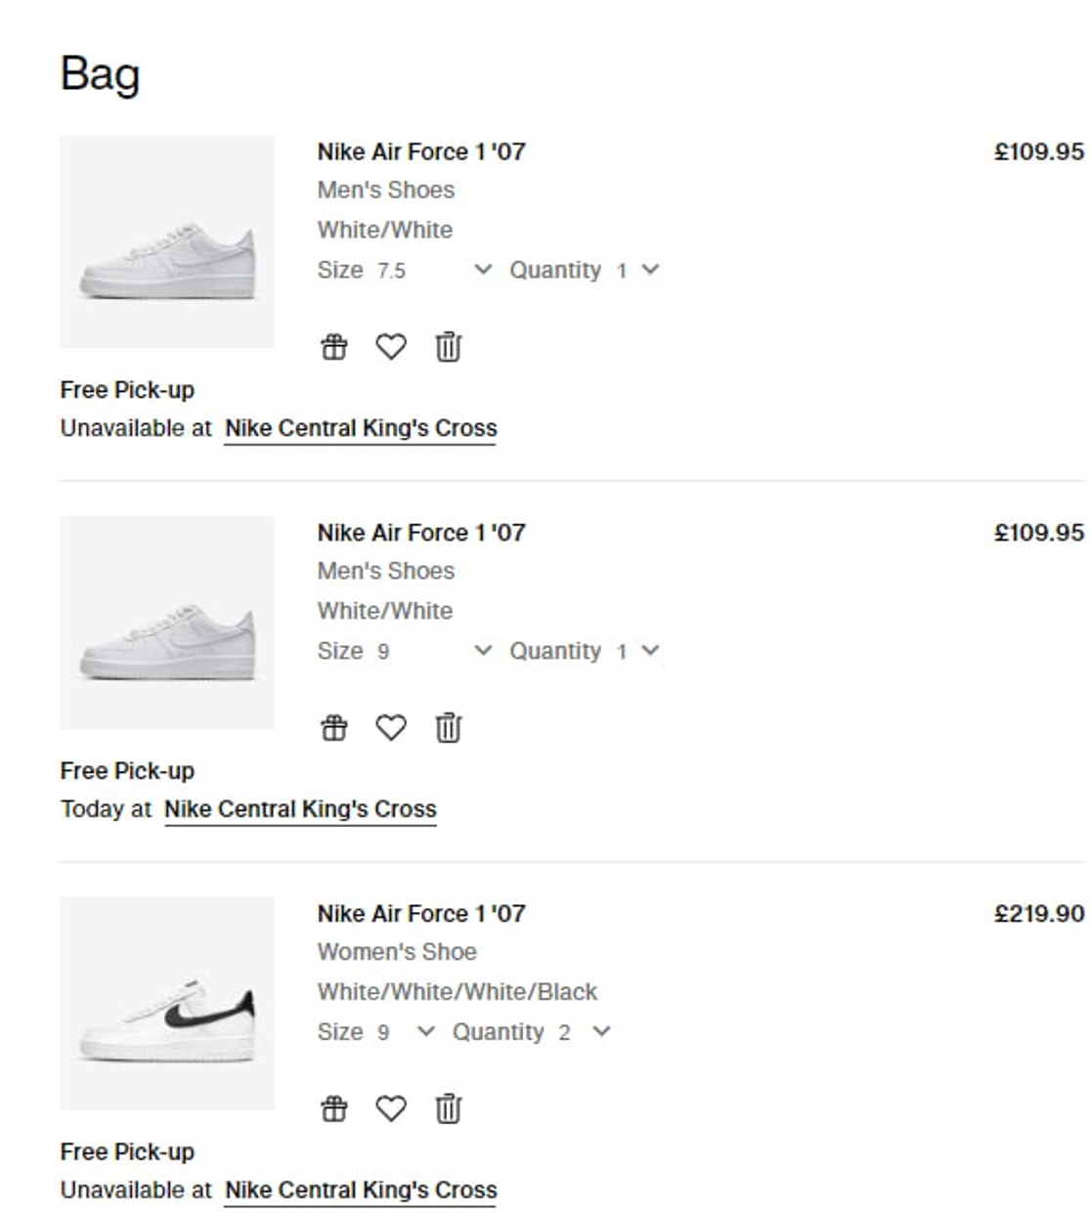

**Wishlist Item:**

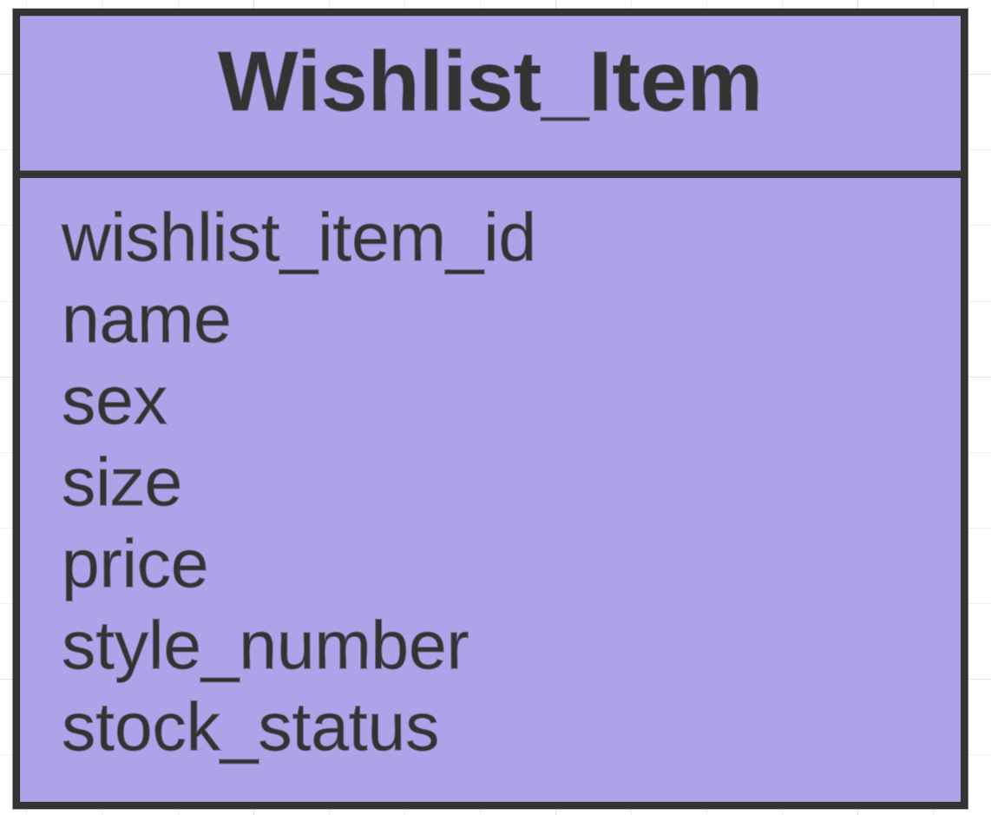

In the actual Nike website there is no “Wishlist”, instead it is called “Favourites”. I renamed it to “Wishlist” because on other sites it is called so.

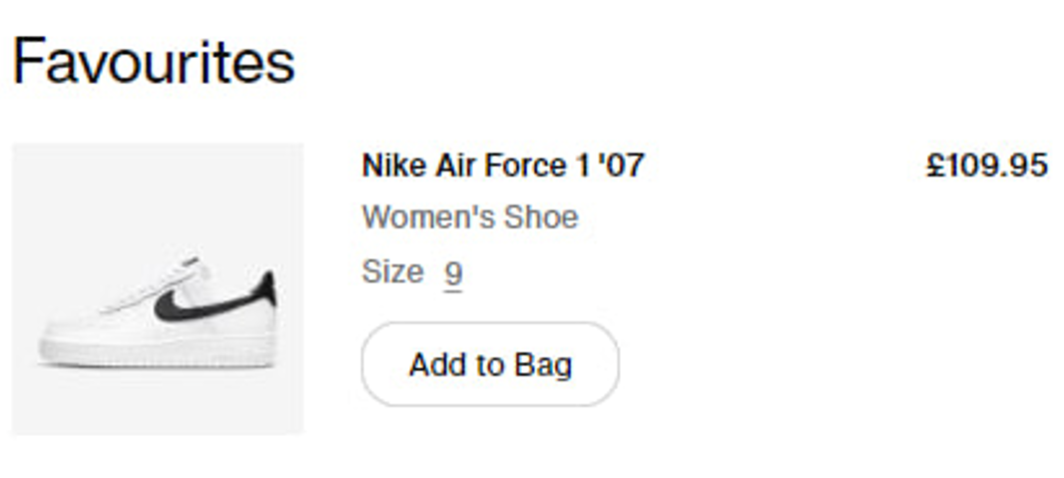

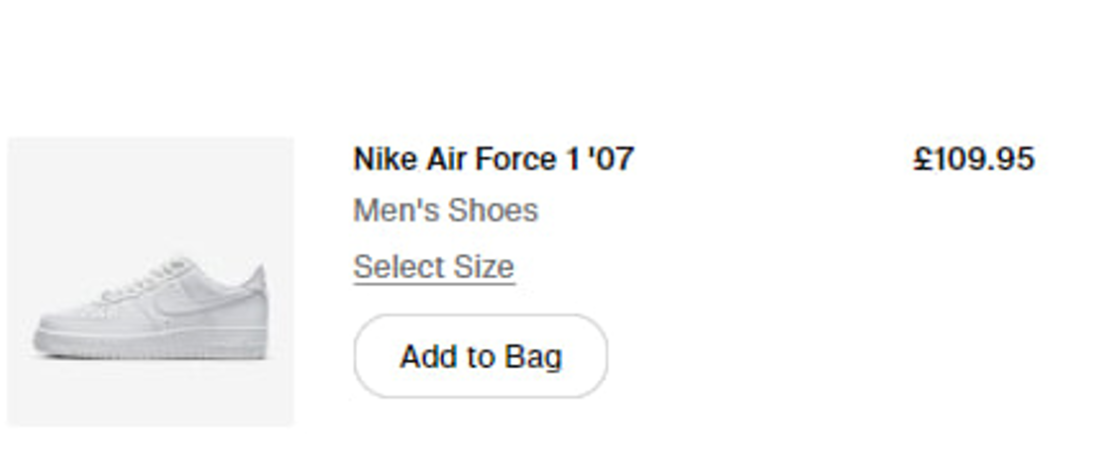

**Product:**

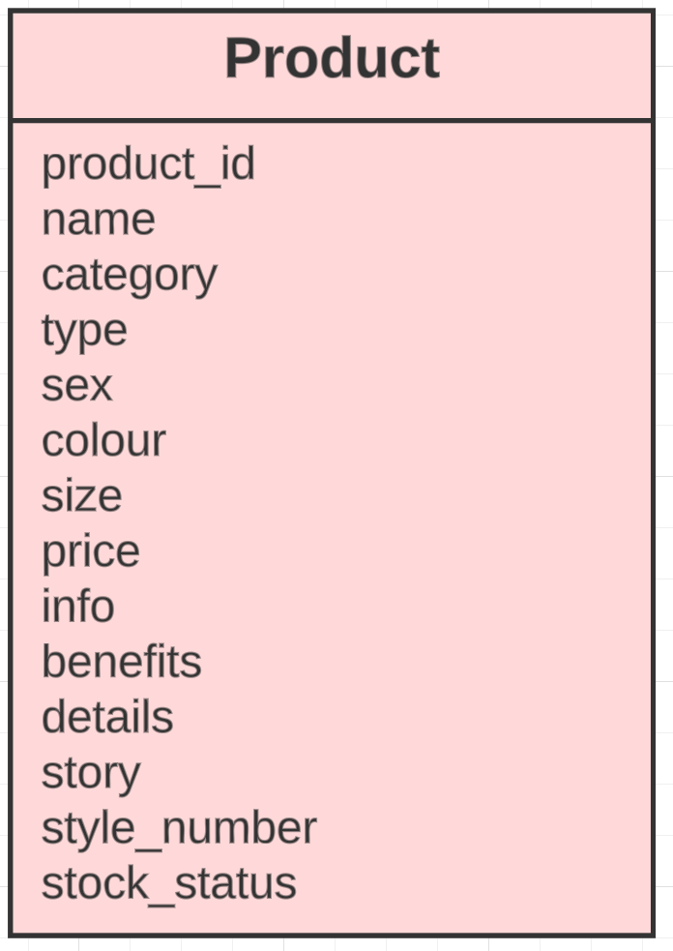

Here I found secret attributes such as style number and stock status. They are not shown on the site, but they exist.

Here you can see the categories of products such as “Men”, “Women” and “Kids”. And types of products.

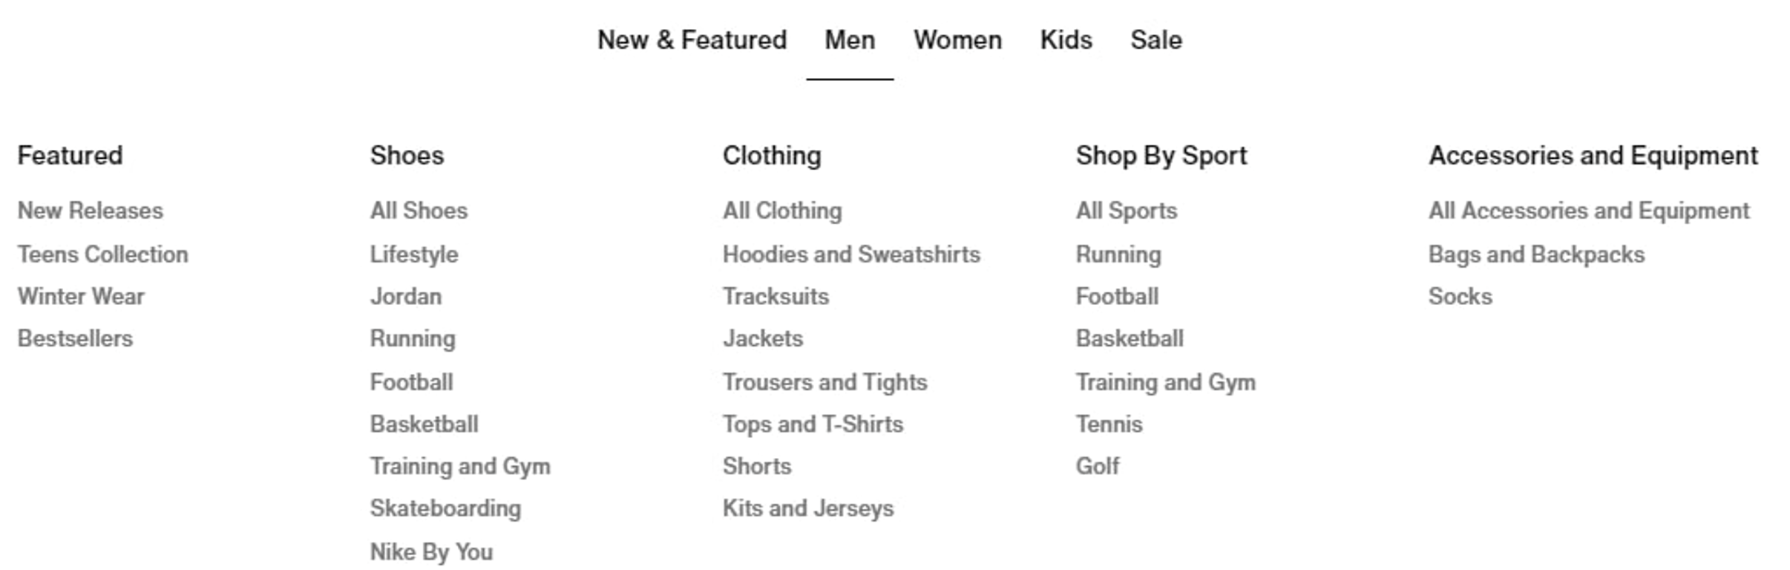

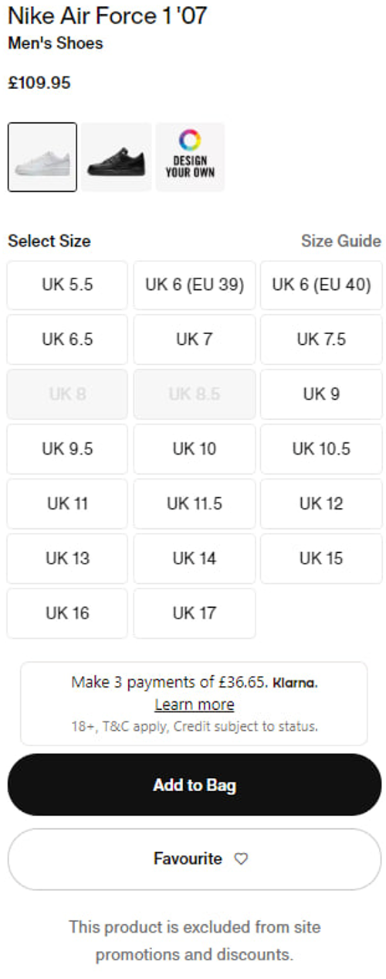

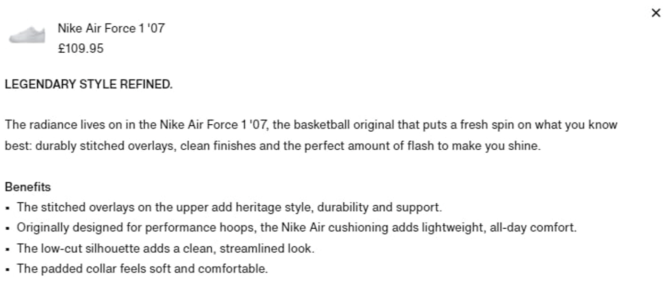

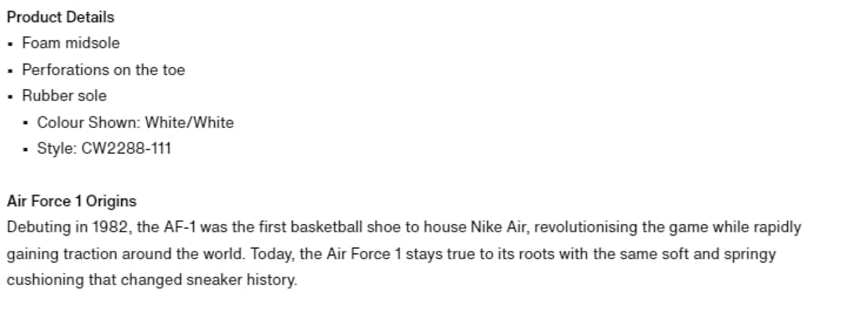

**Order:**

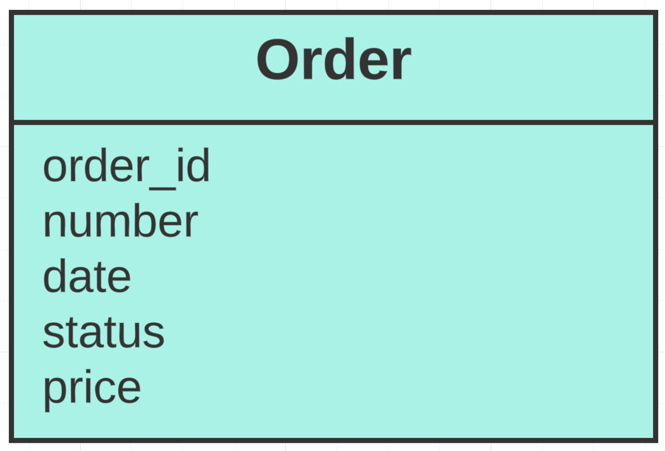

There is no screenshot for this entity because it’s a hidden entity. All orders will have its own: number, date, status and price.

**Review:**

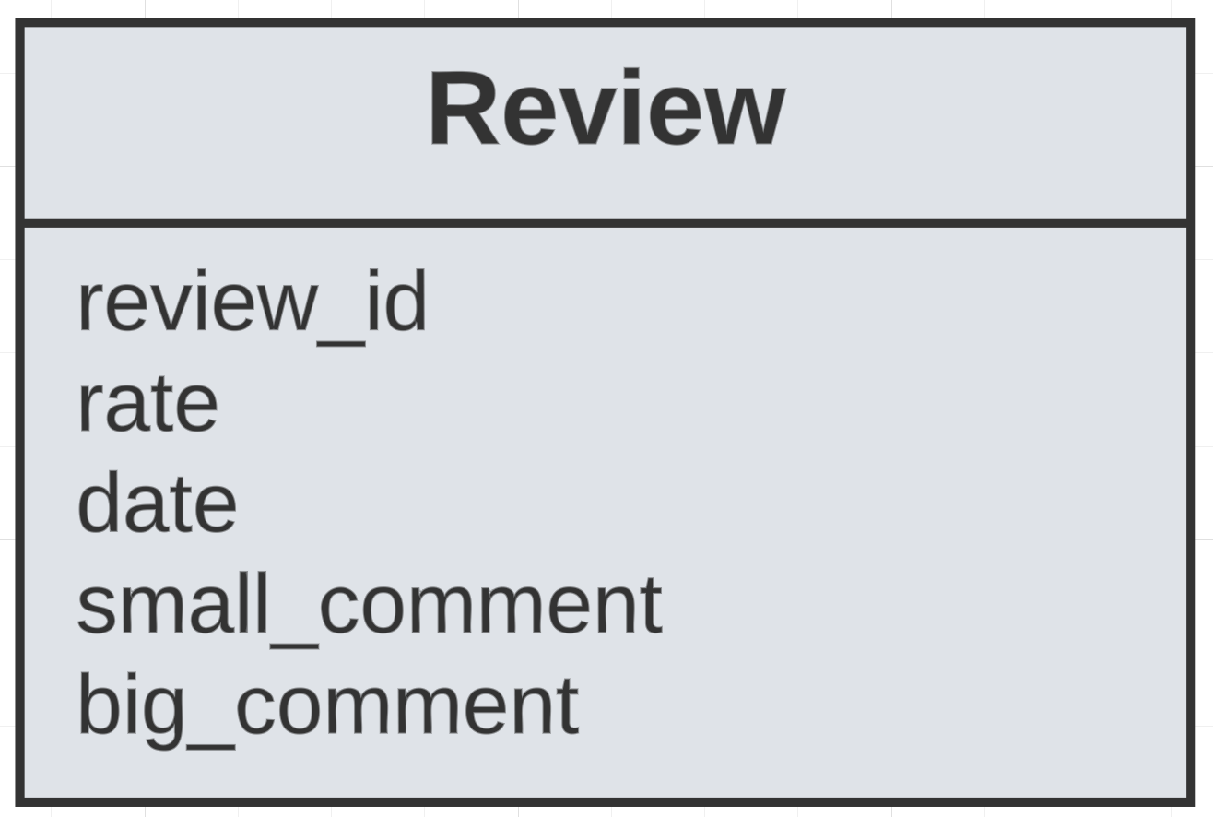

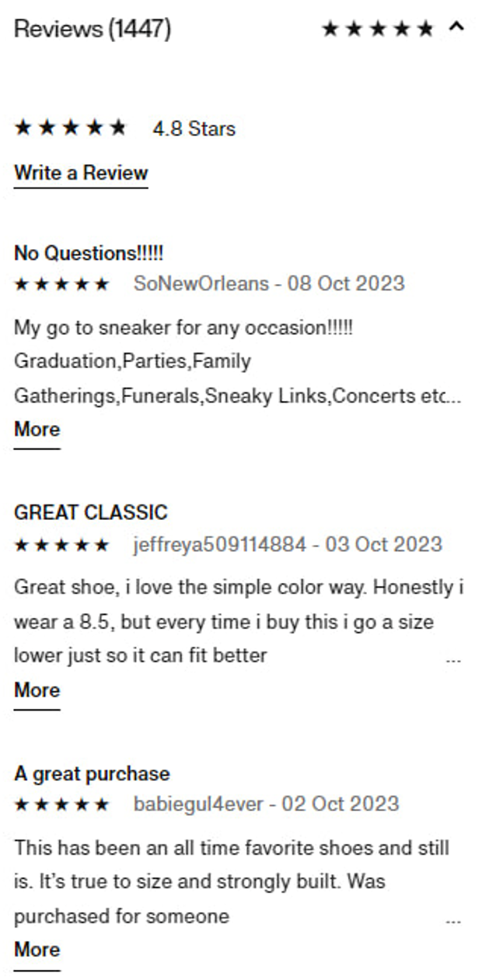

**Store:**

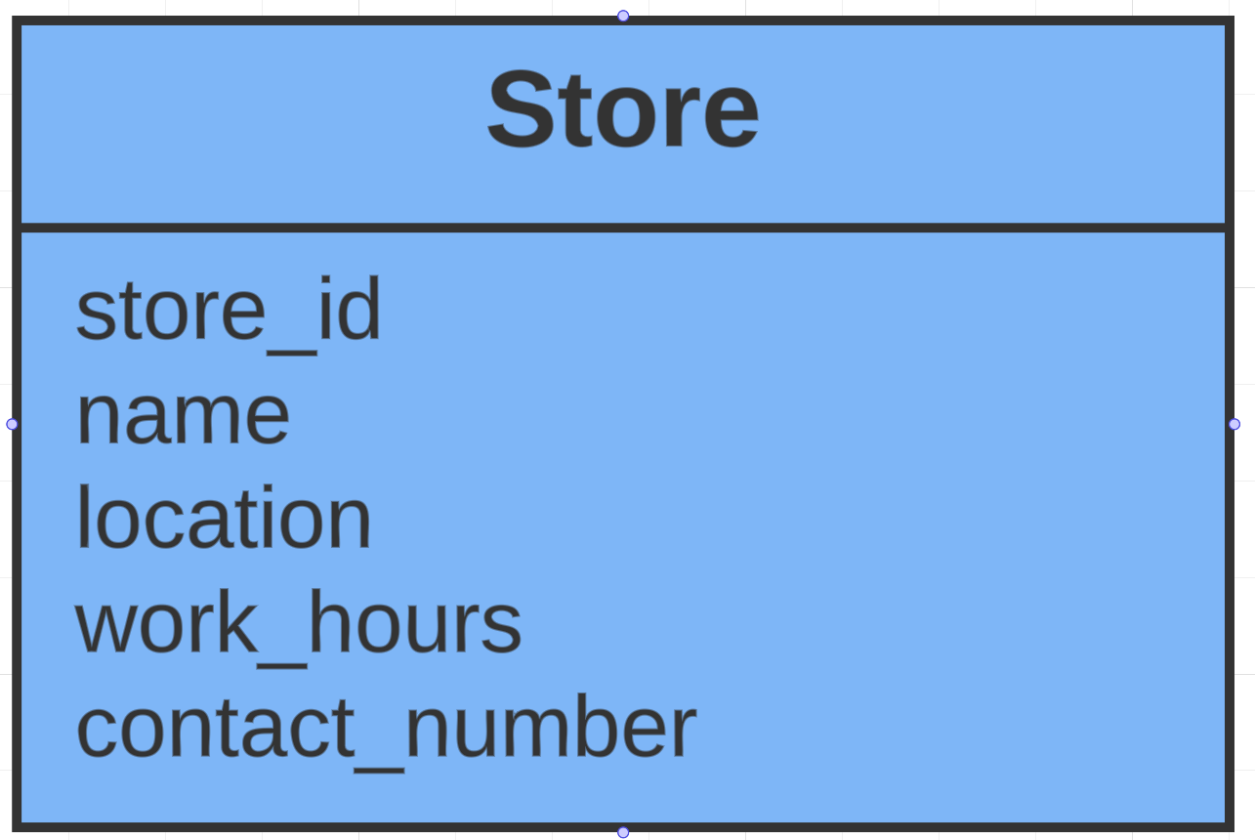

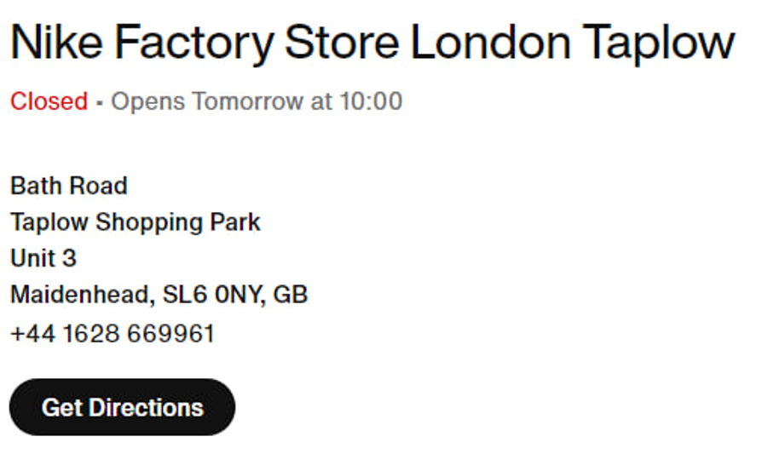

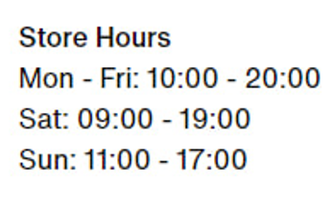

**Event:**

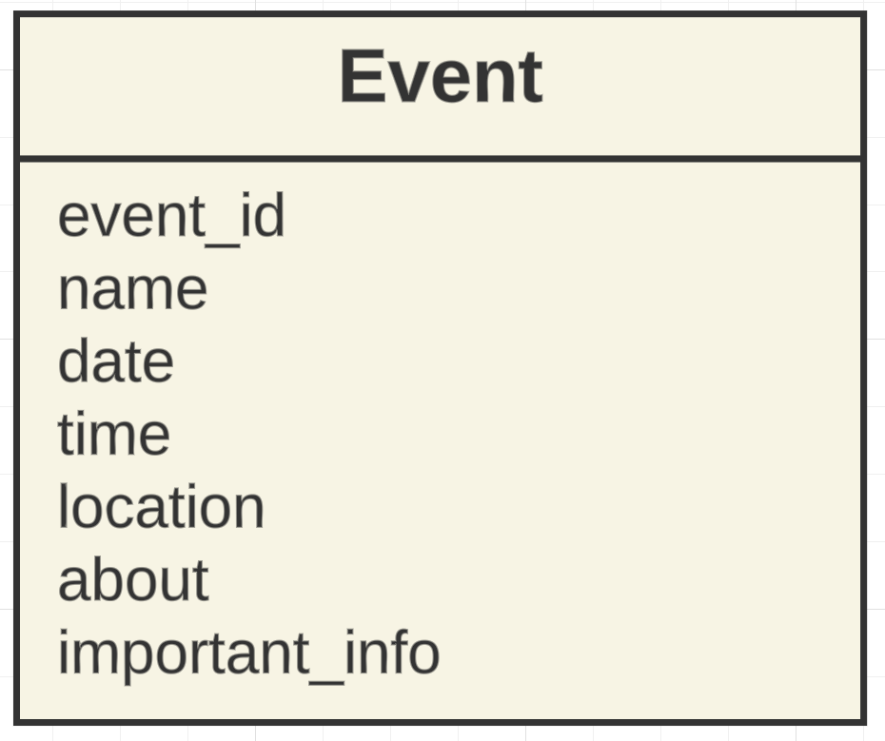



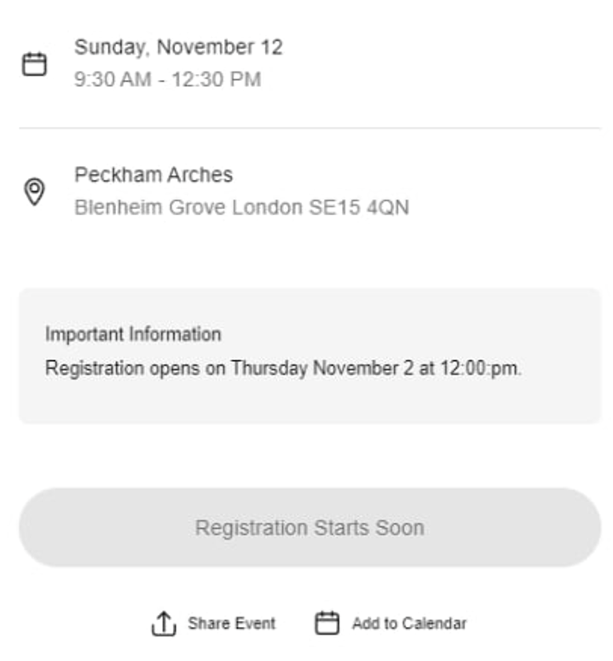

**Interest:**

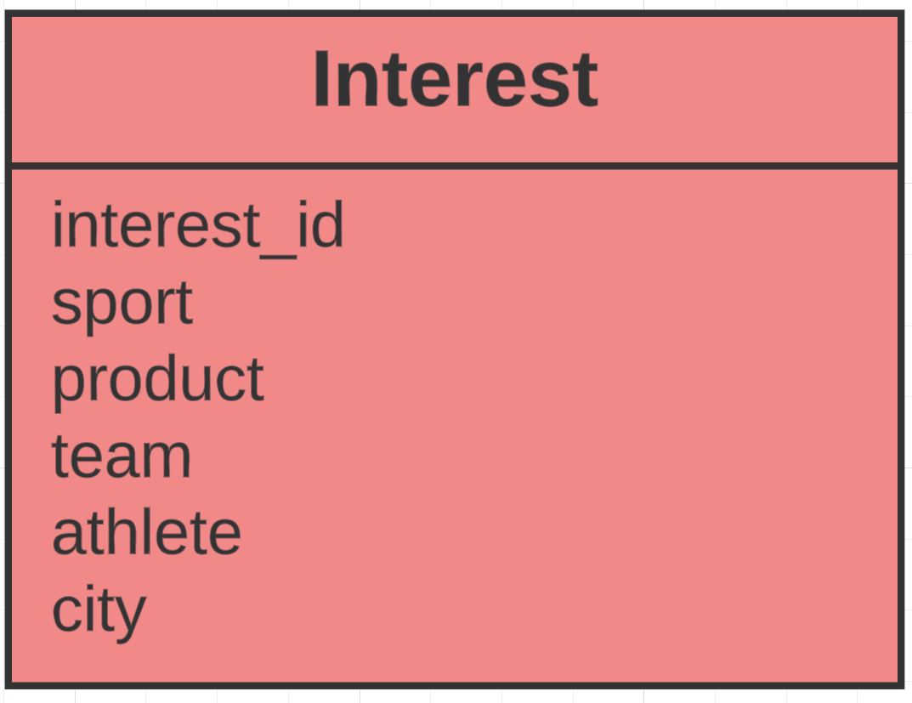

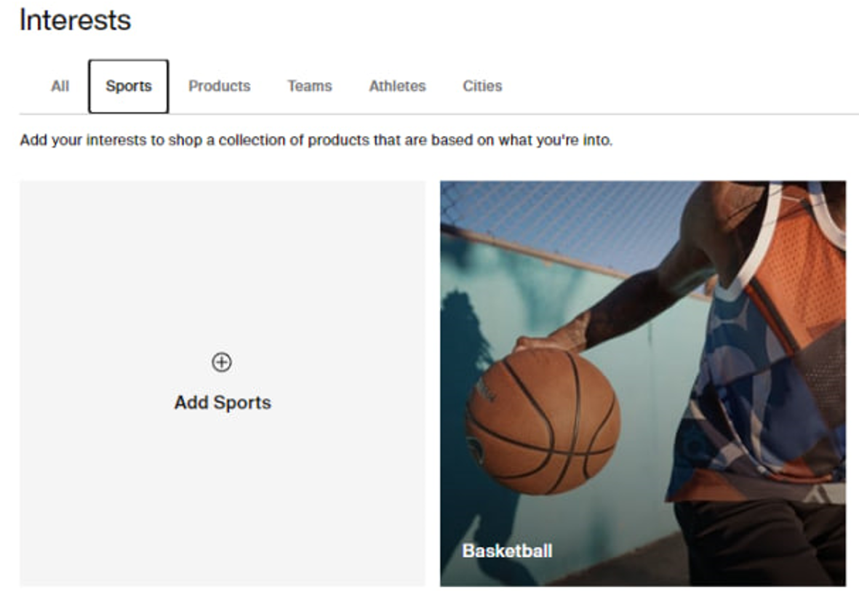

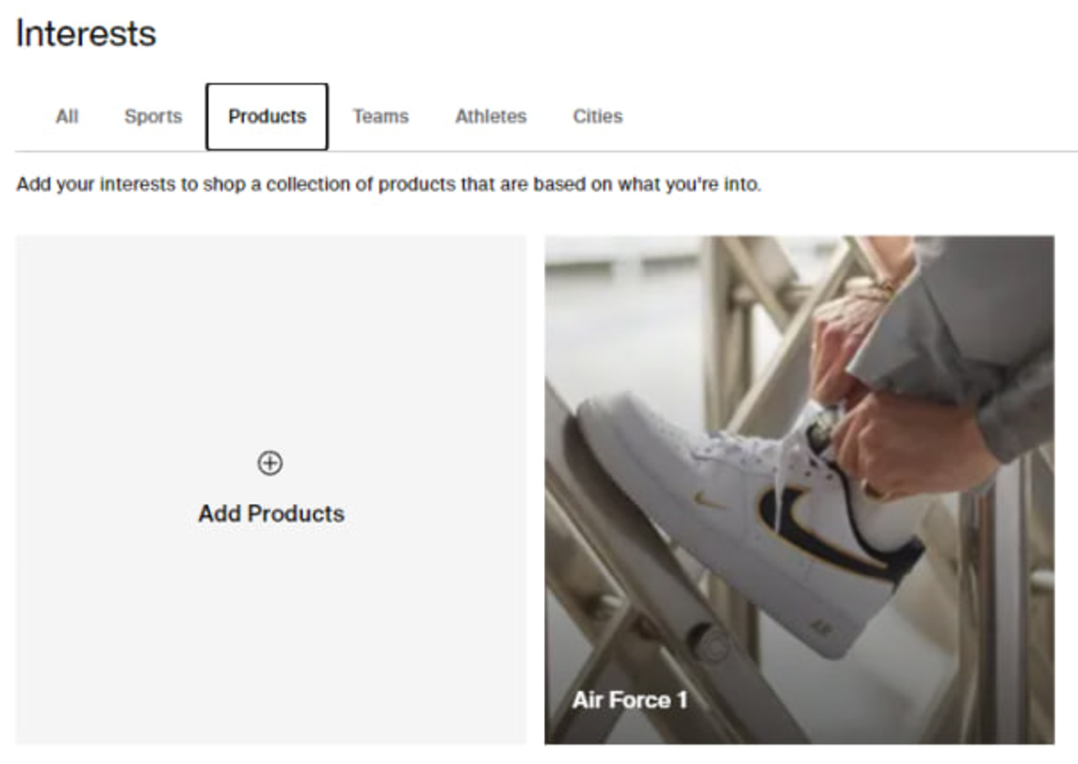

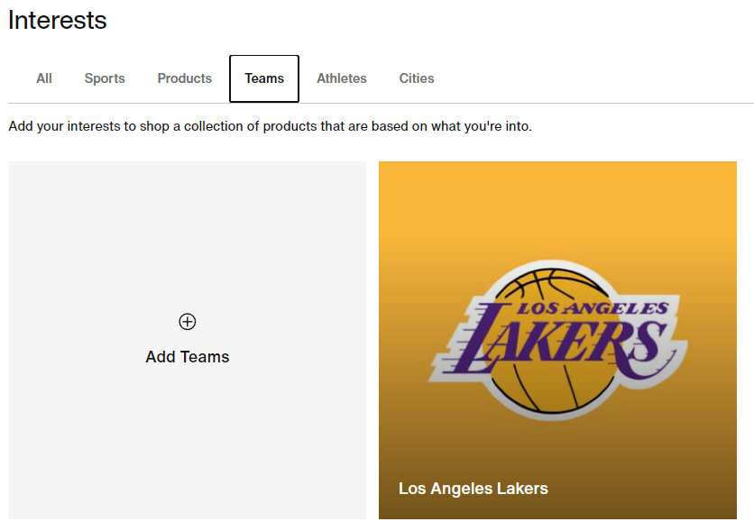

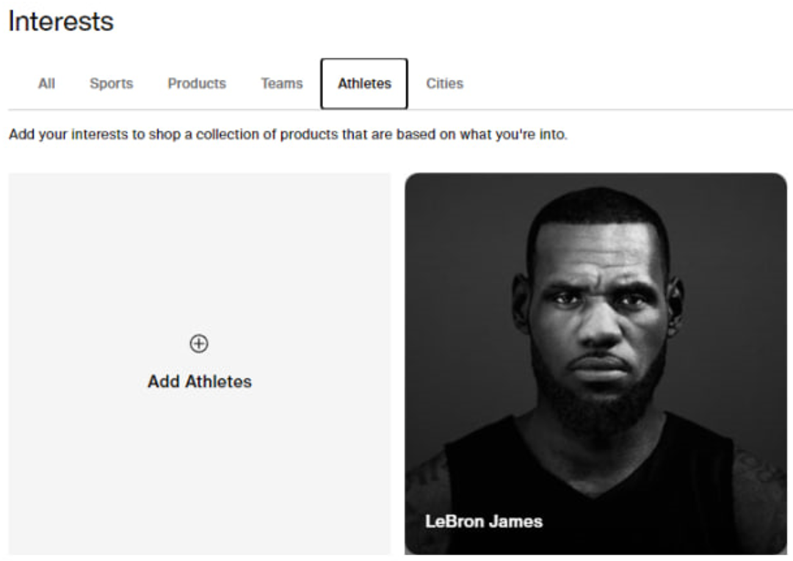

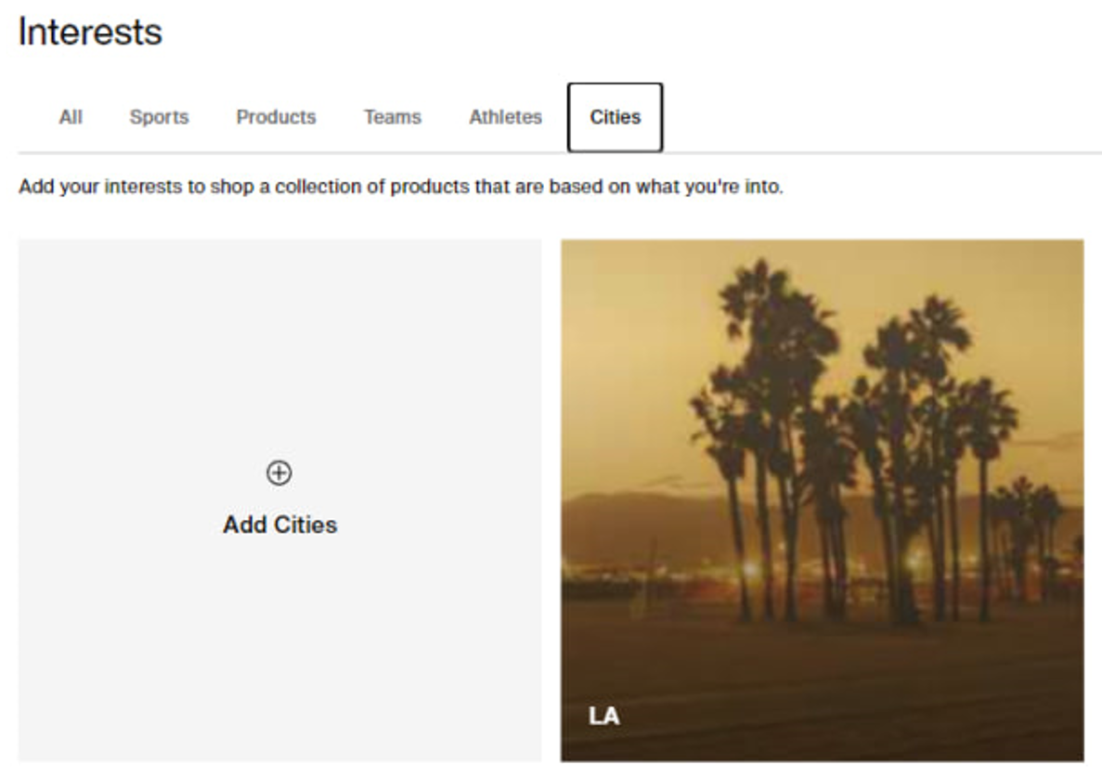

### **List of data fields from Adidas**

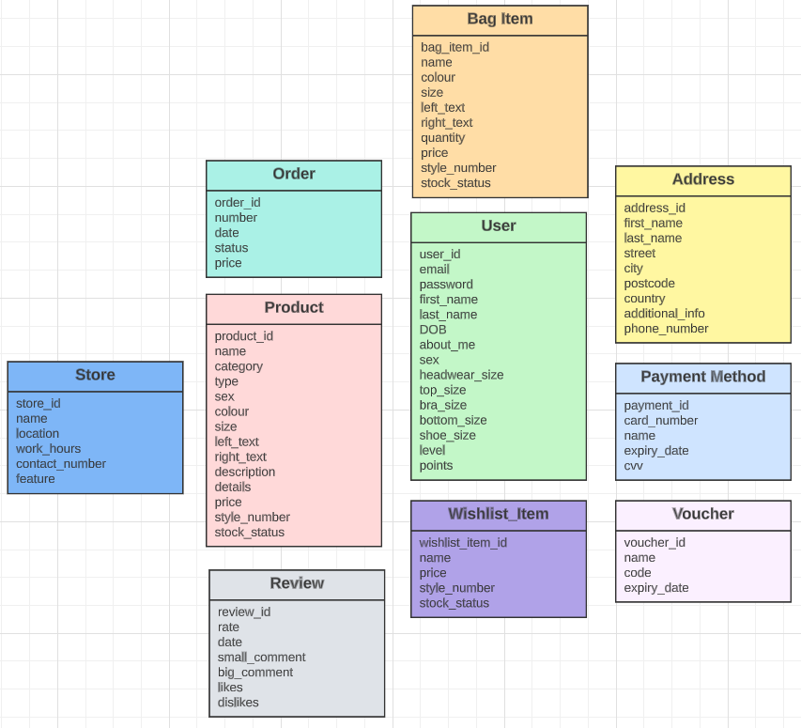

All screenshots that are shown for this site were taken from Adidas website. (Adidas, 2023)

**User:**

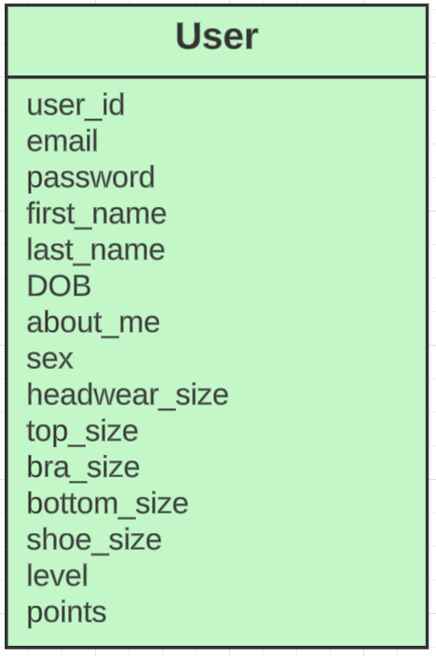

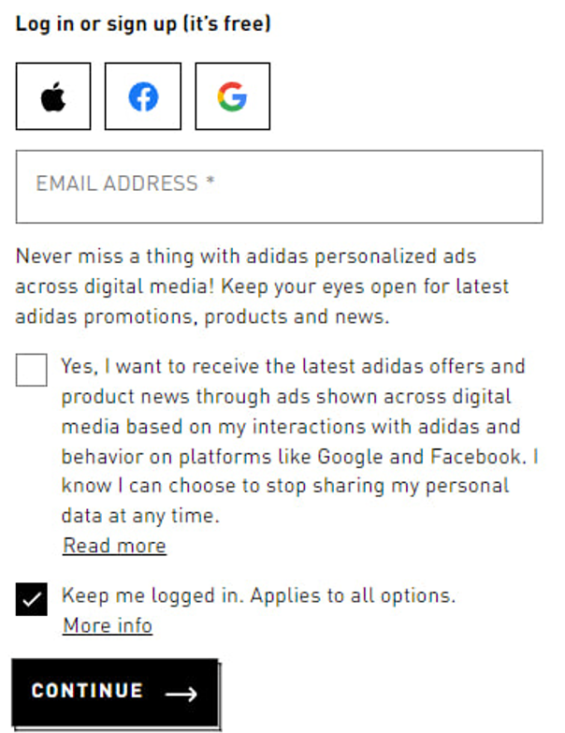

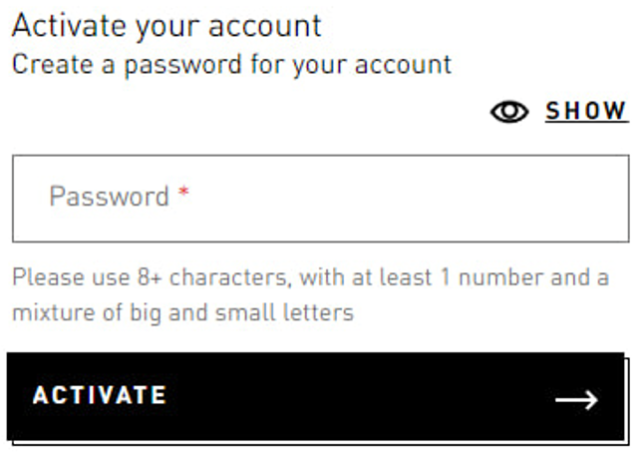

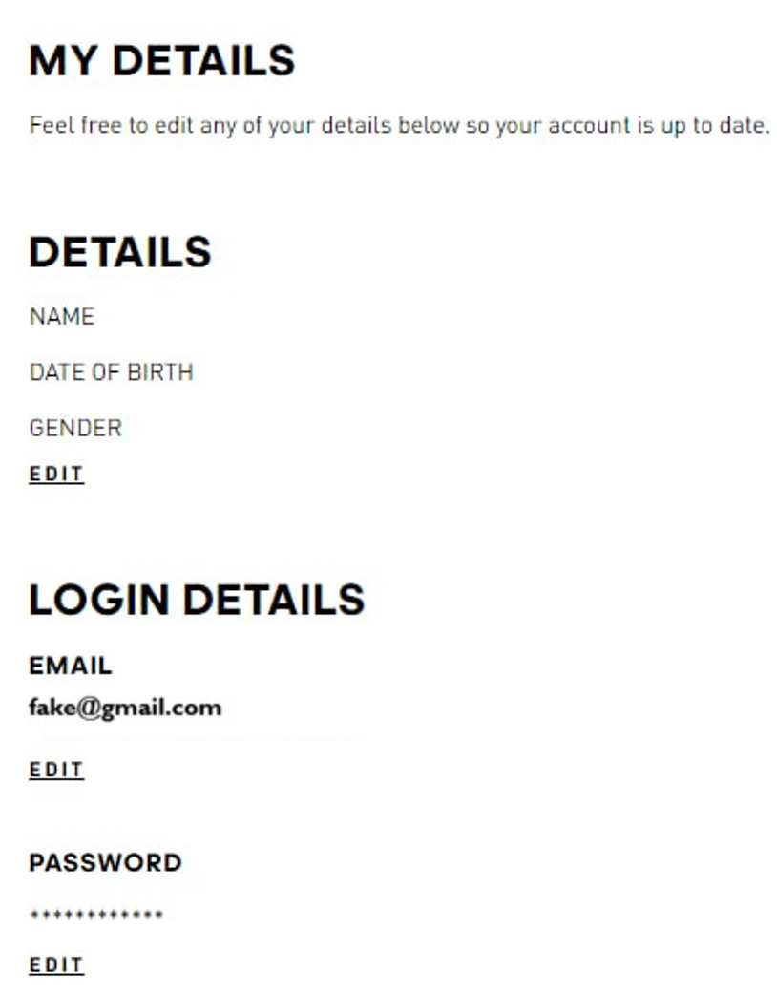

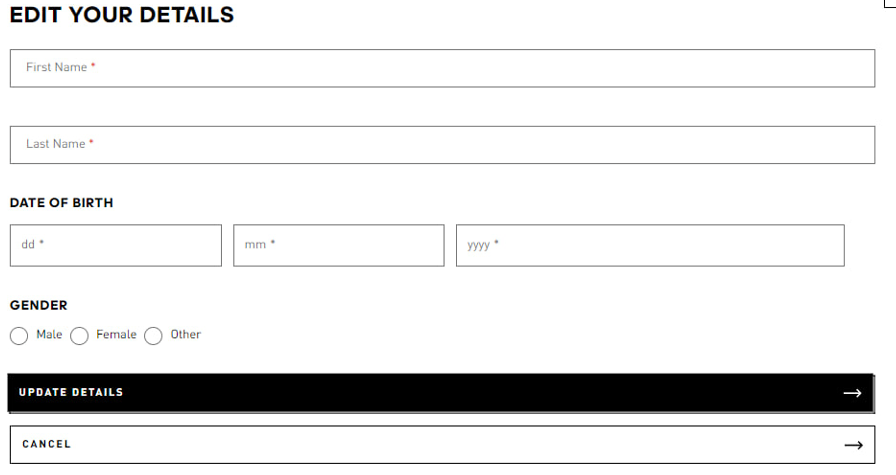

User can provide his size of the body: headwear, top, bra, bottom, shoe. I will provide just headwear and top sizes for you to see how it looks.

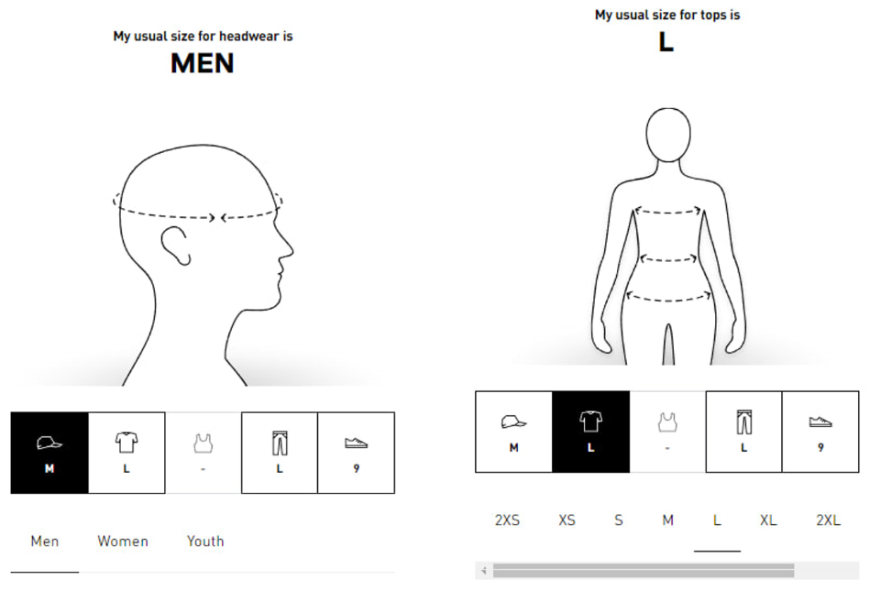

Each user also has a club level and club points:

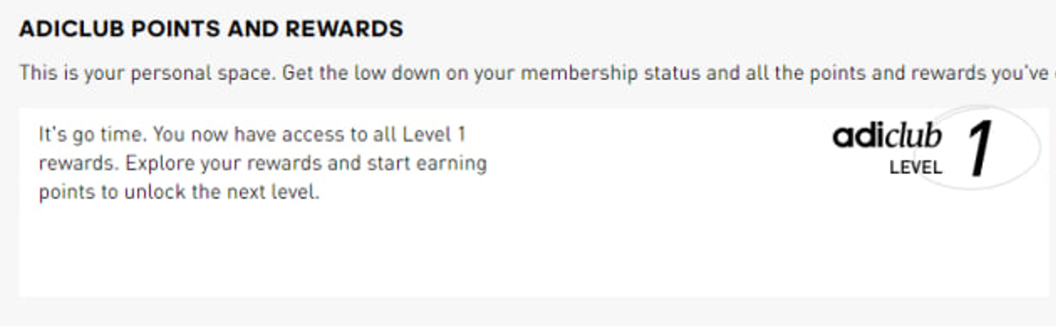

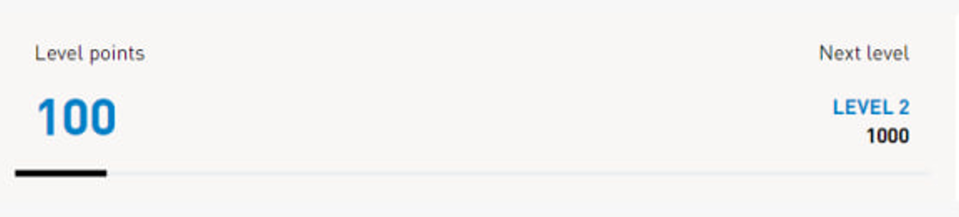

**Address:**

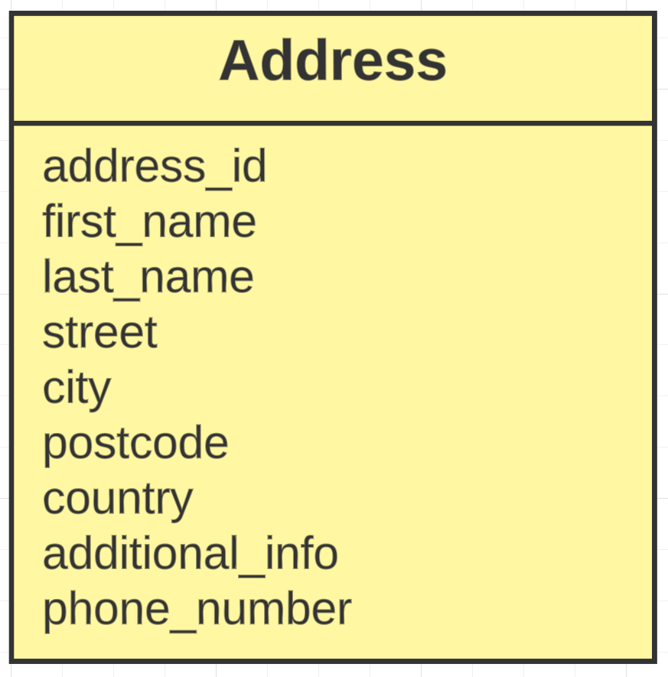

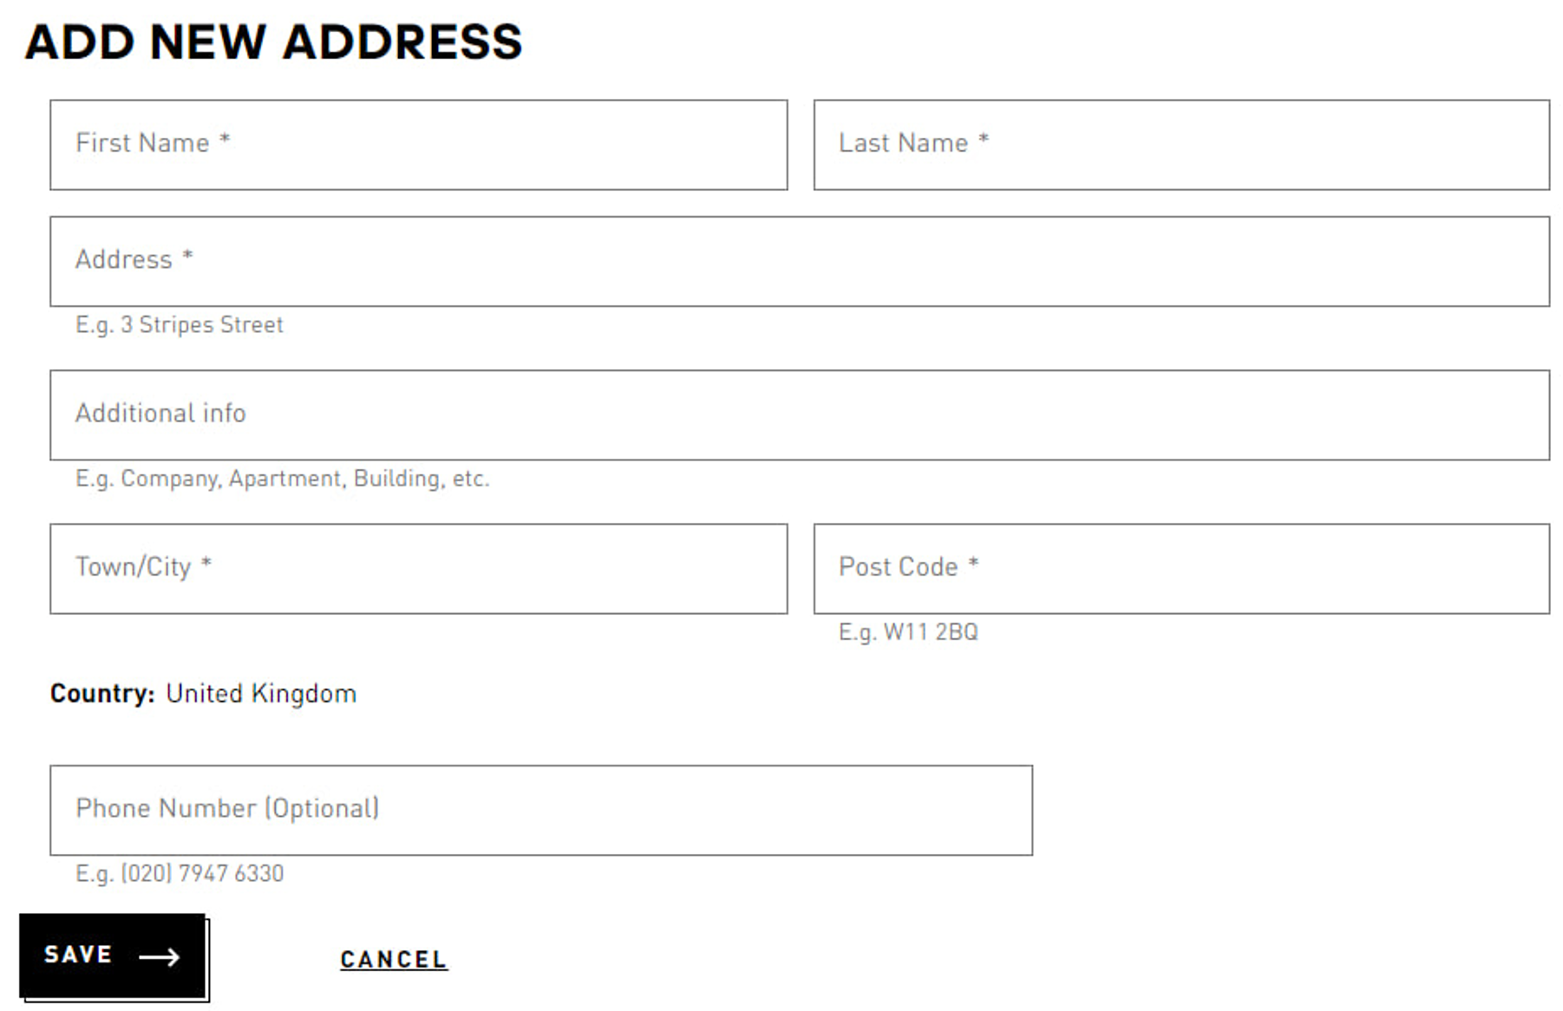

**Payment Method:**

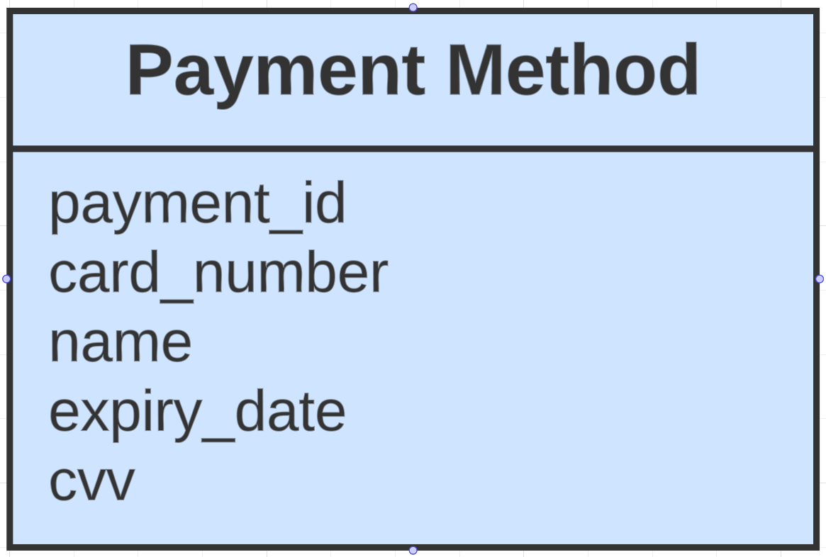

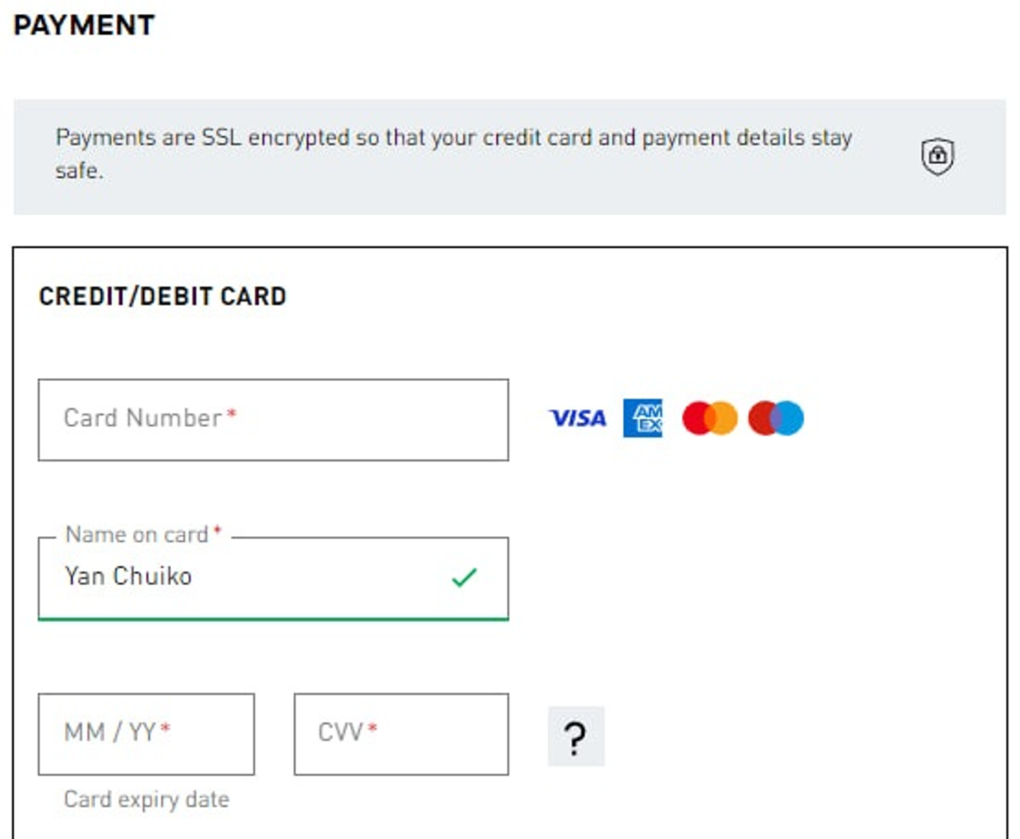

**Bag Item:**

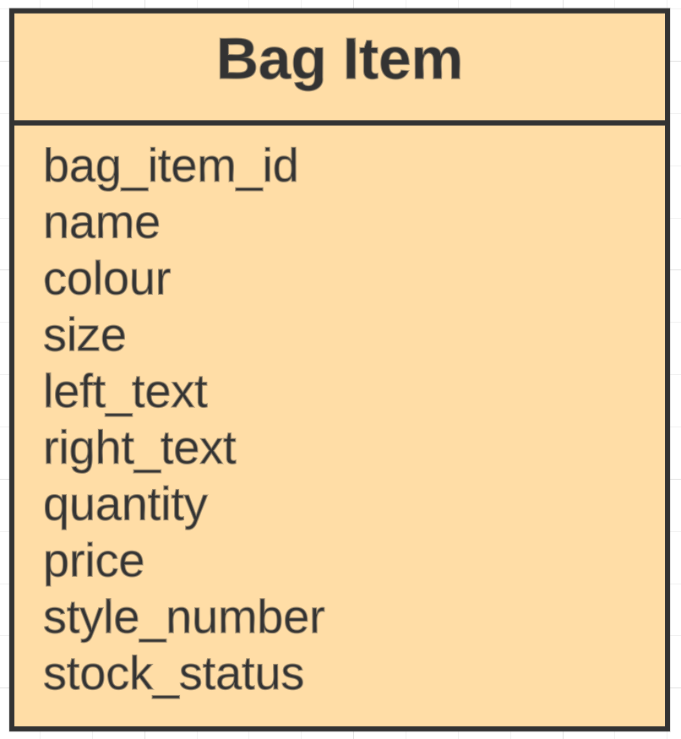

Here you can see the difference between Nike and Adidas. In Adidas website you can add right and left text for the product. You can do this before payment in the bag. On the Nike website you can’t do this.

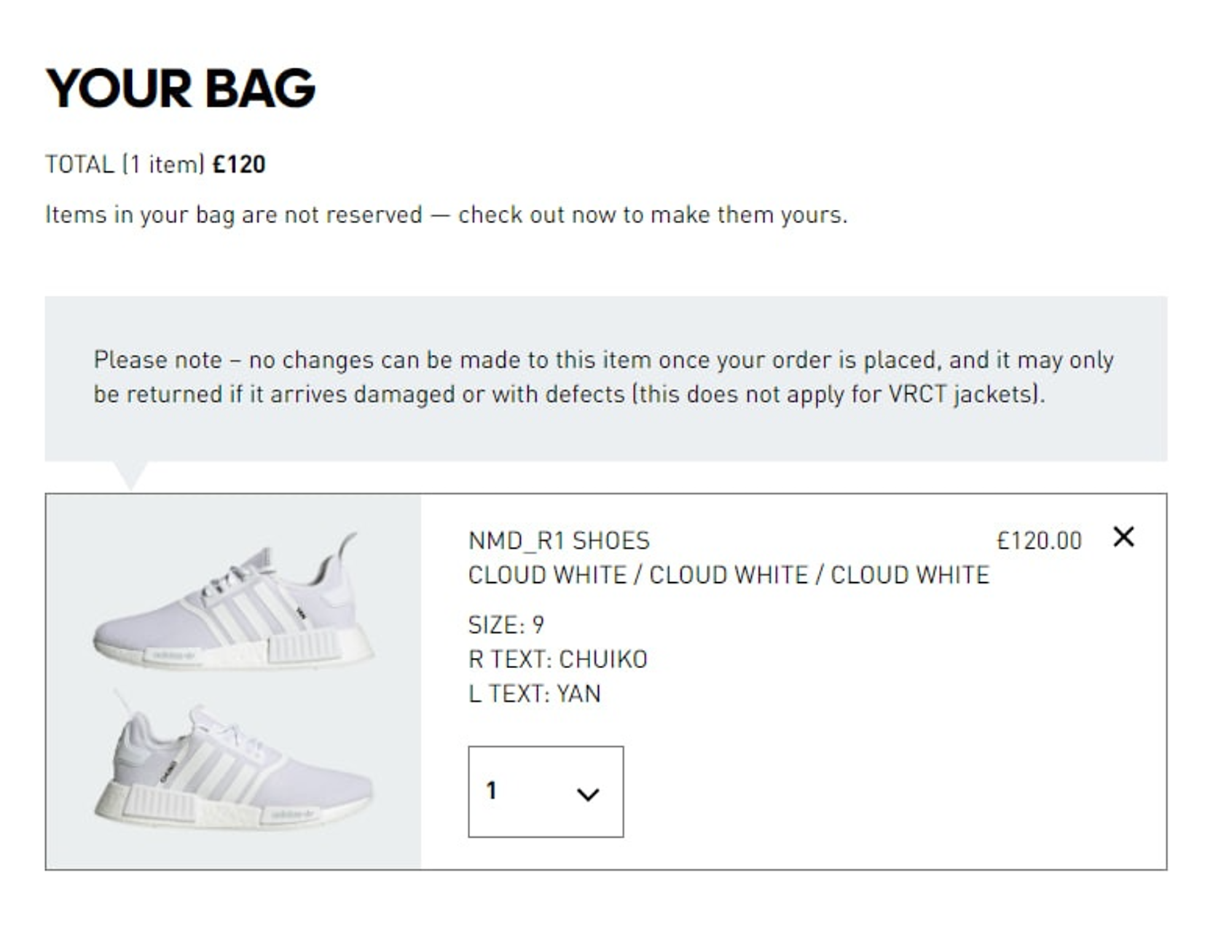

**Wishlist Item:**

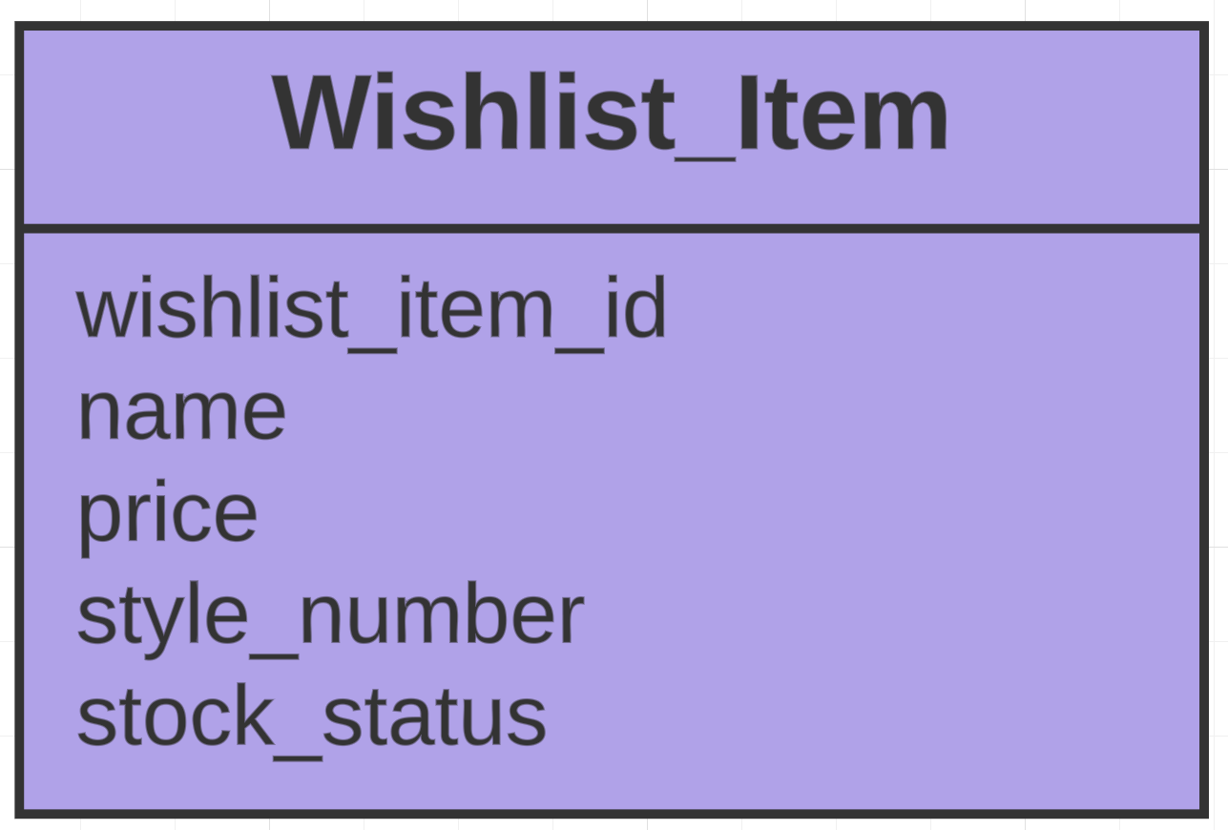

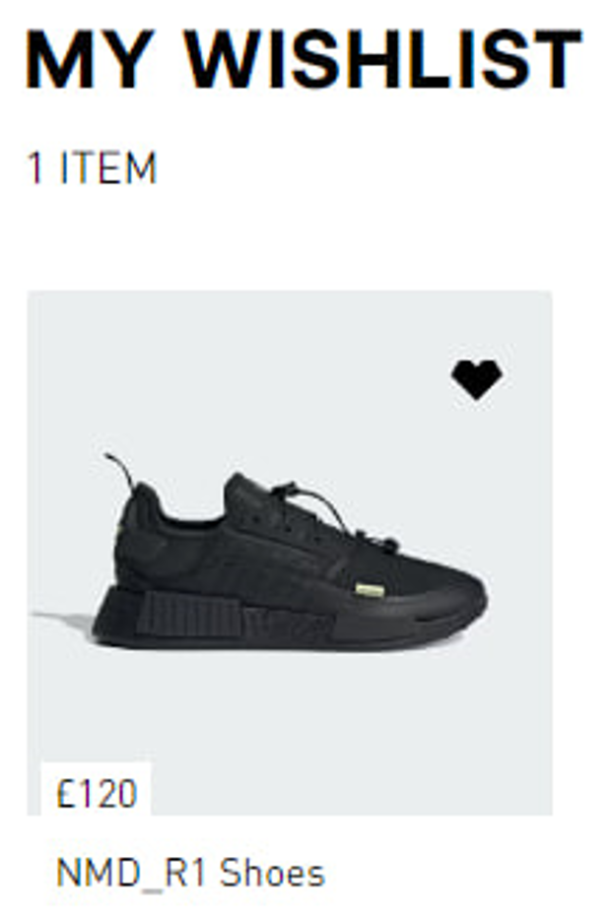

**Product:**

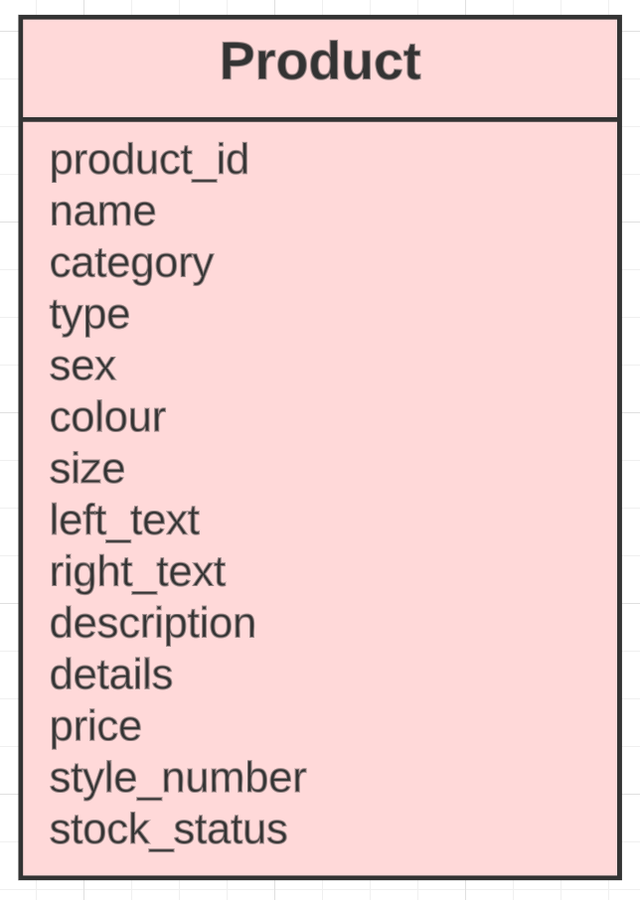

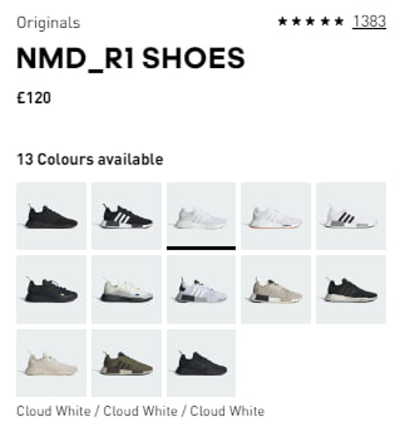

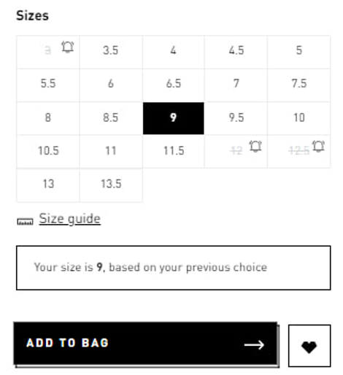

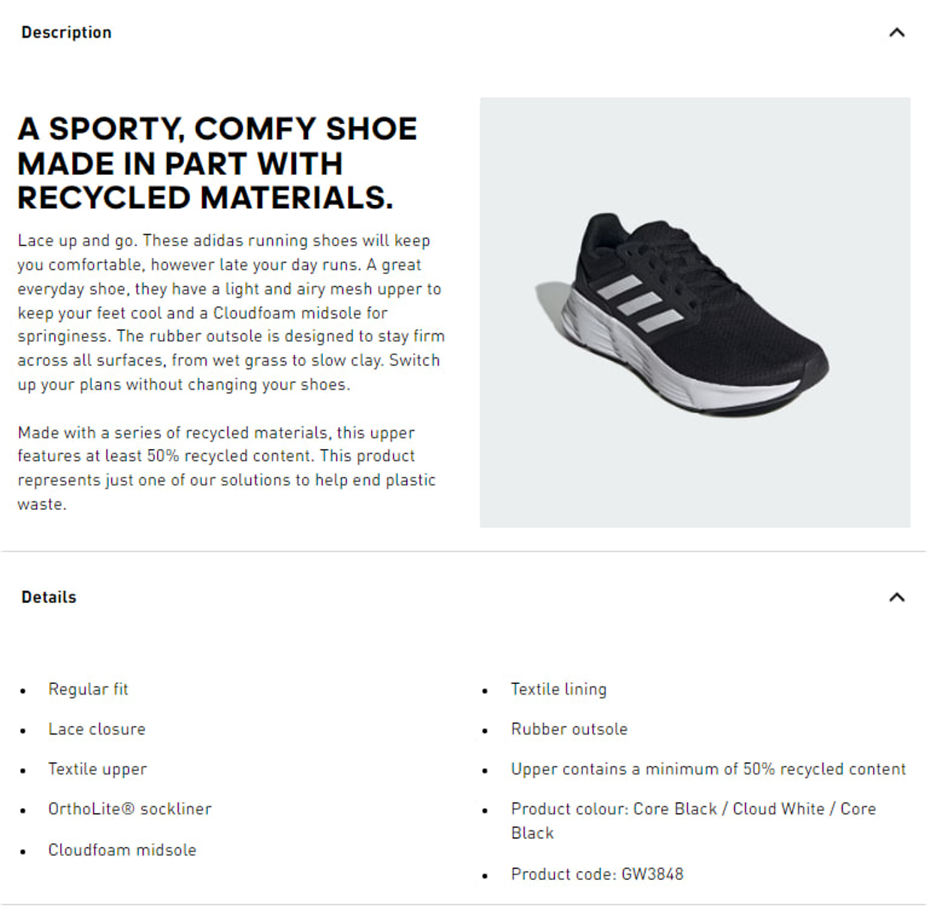

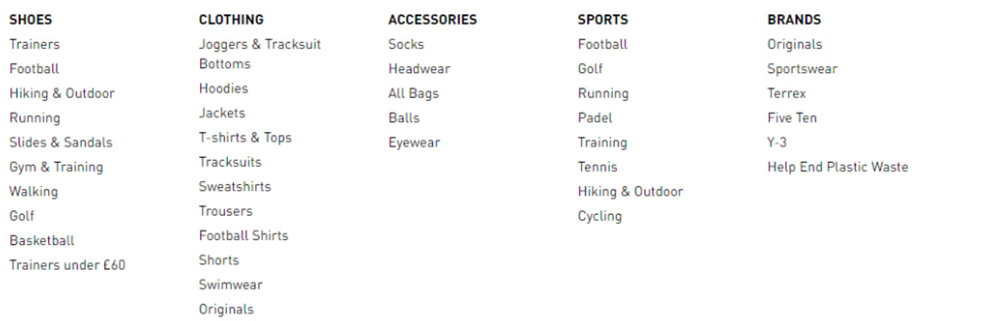

**Order:**



**Review:**

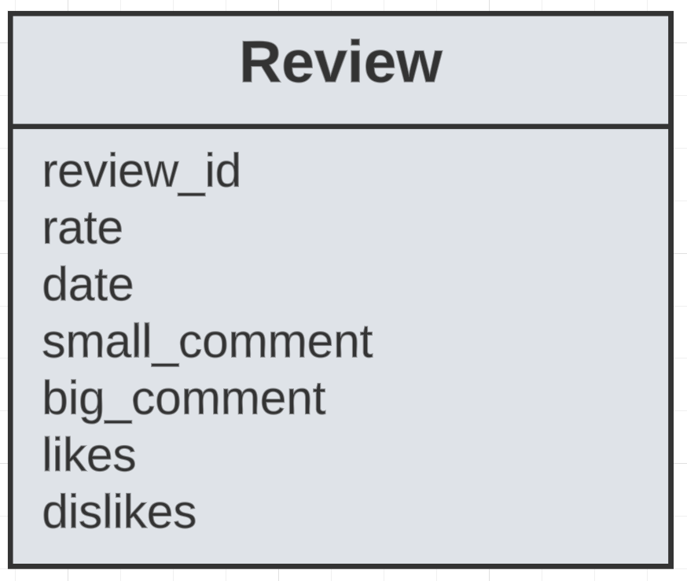

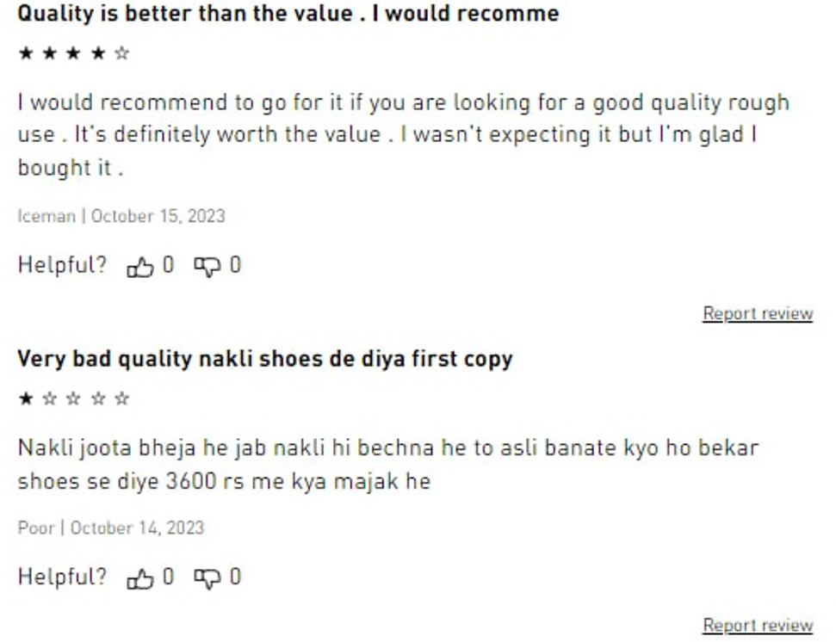

**Store:**

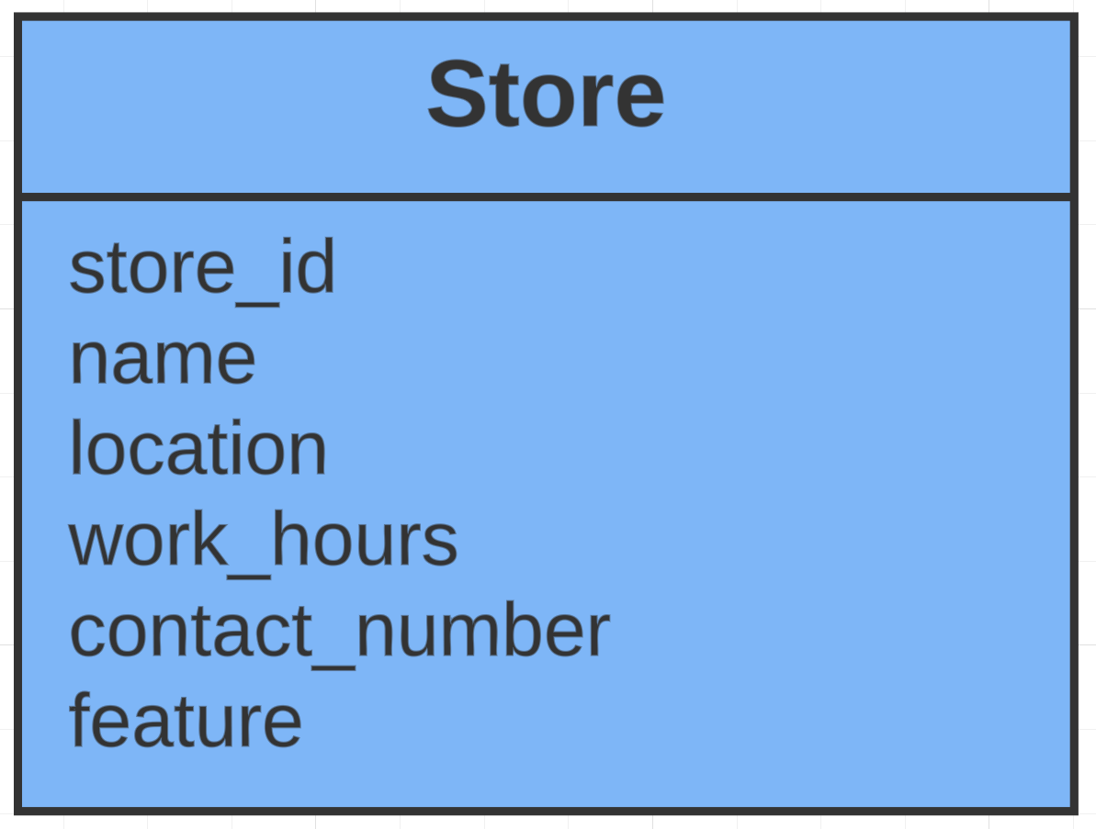

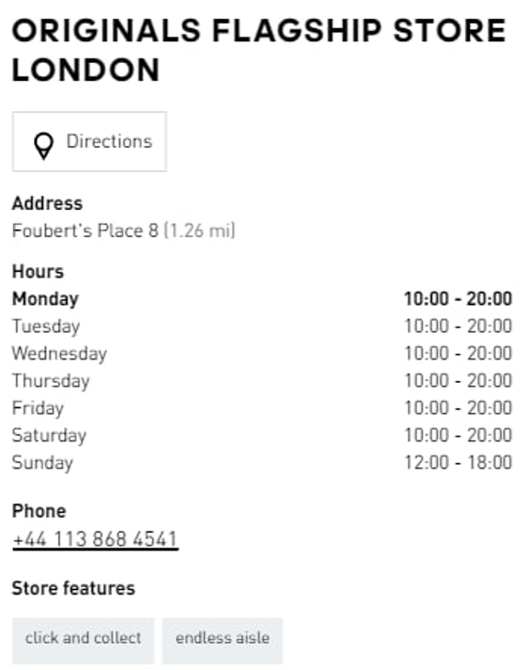

**Voucher:**

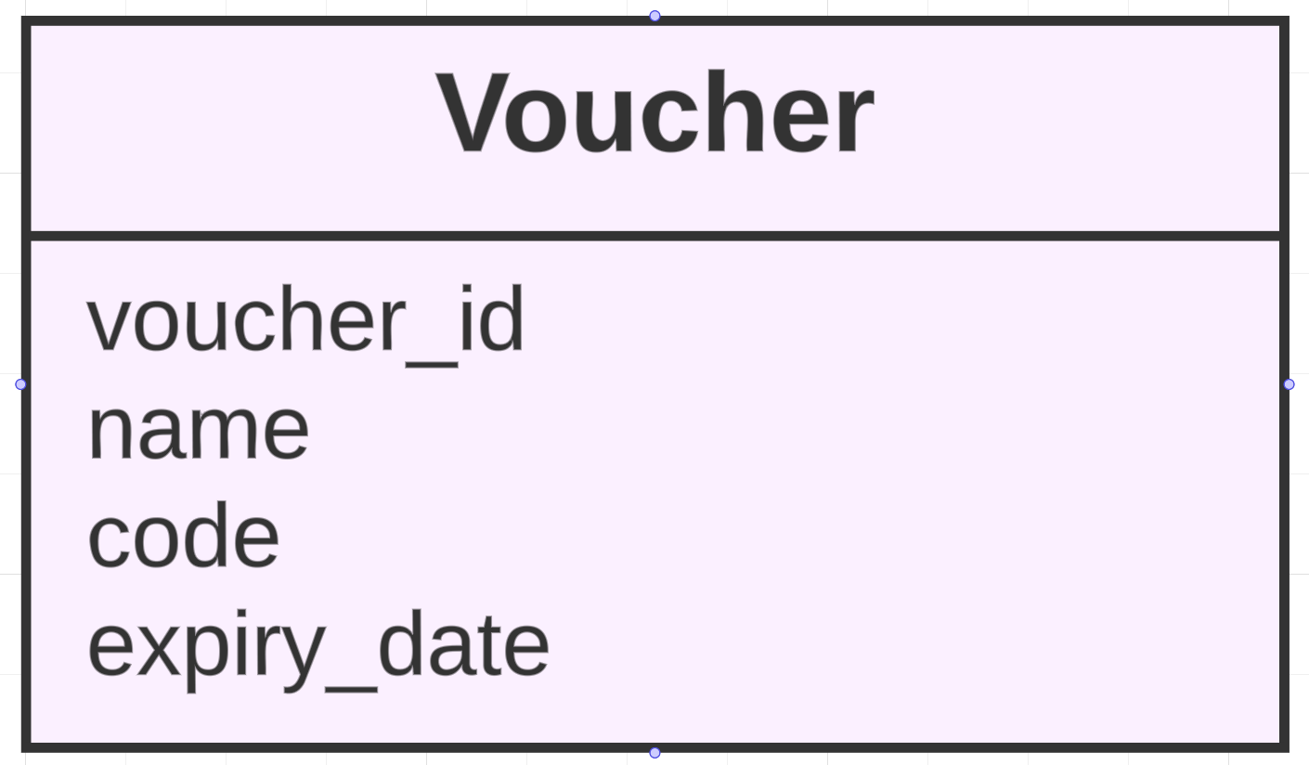

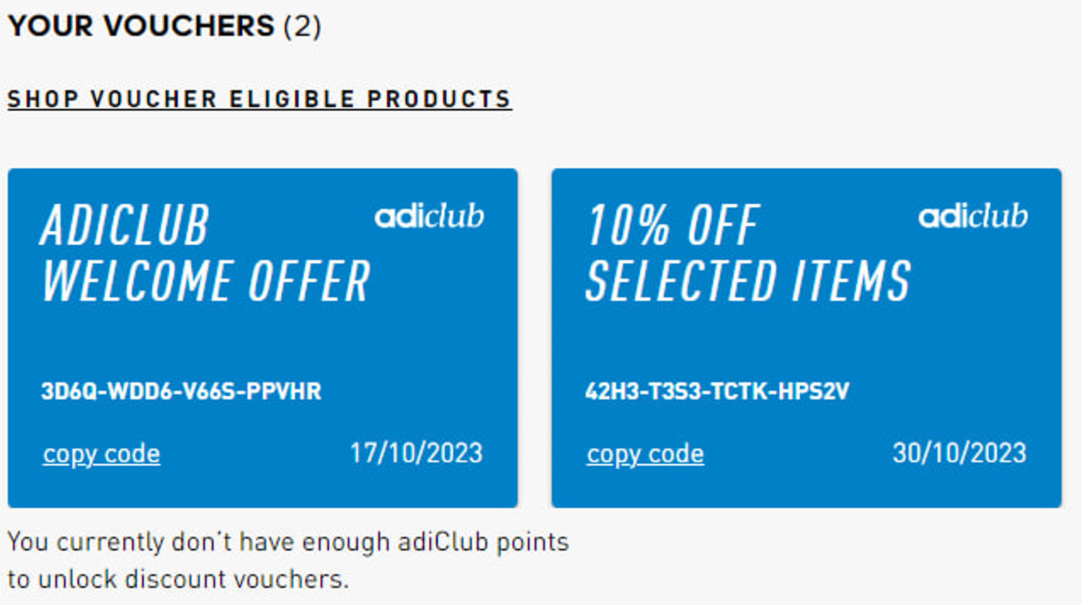

### **List of data fields from Puma**

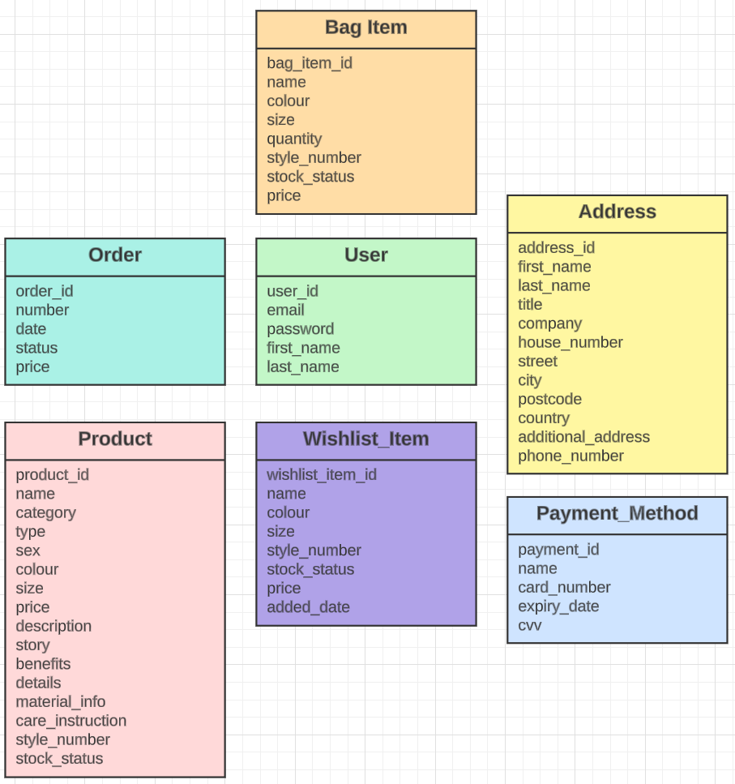

All screenshots that are shown for this site were taken from Puma website. (Puma, 2023)

**User:**

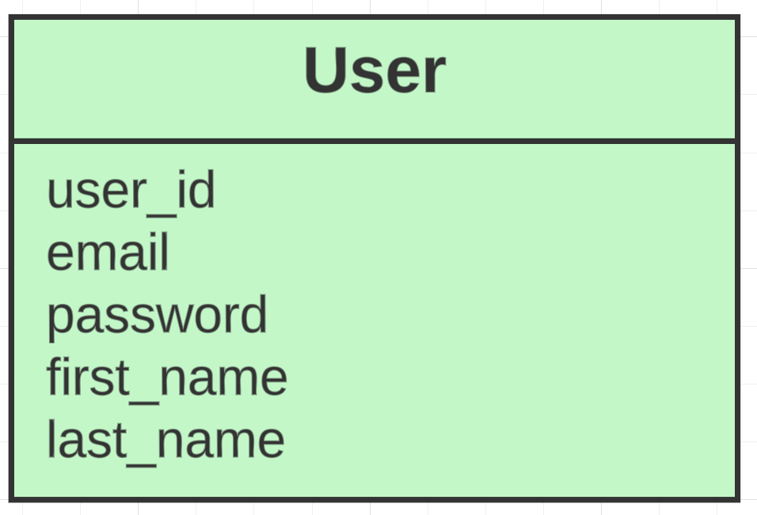

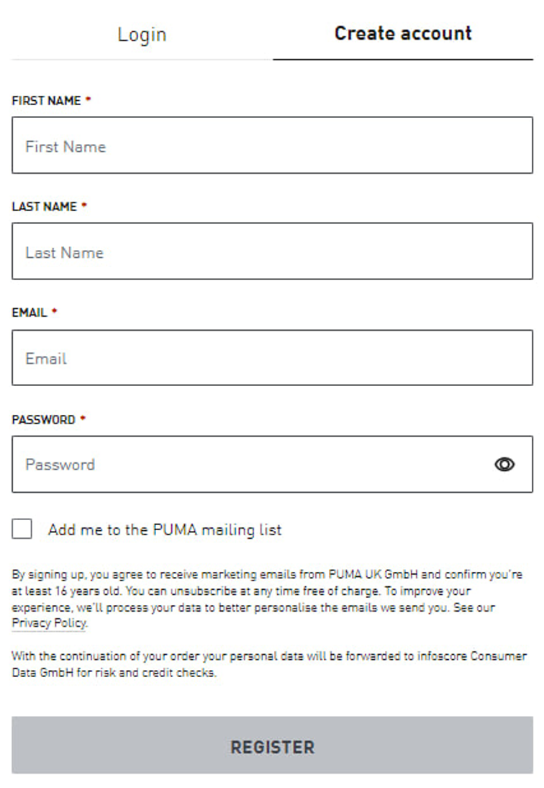

**Address:**

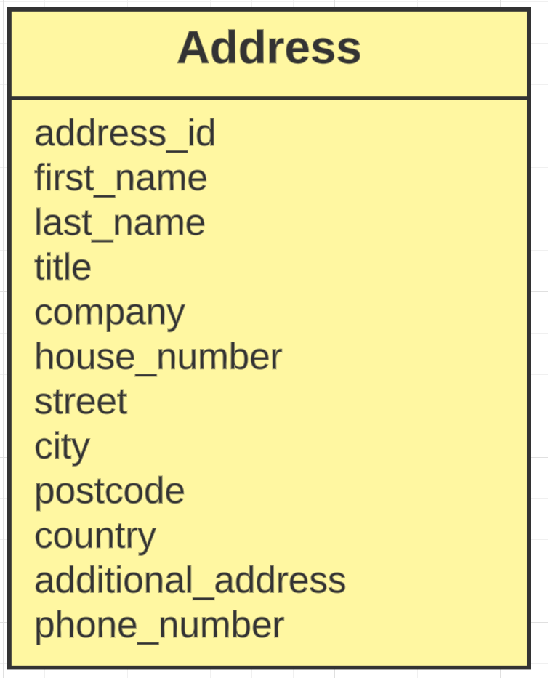

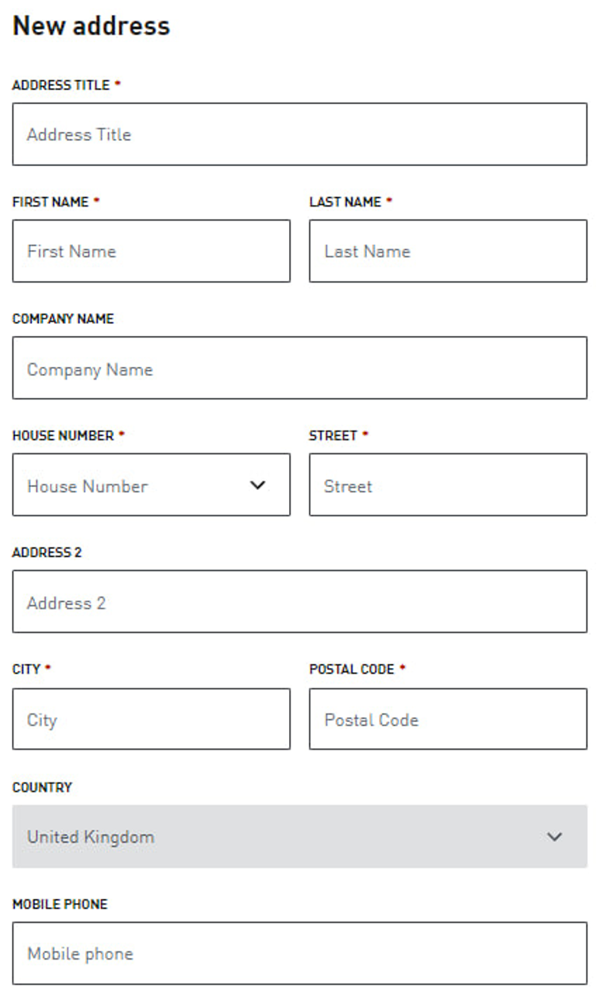

**Payment Method:**

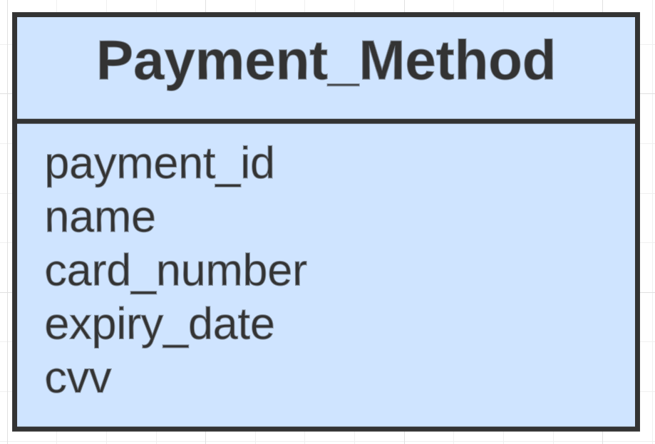

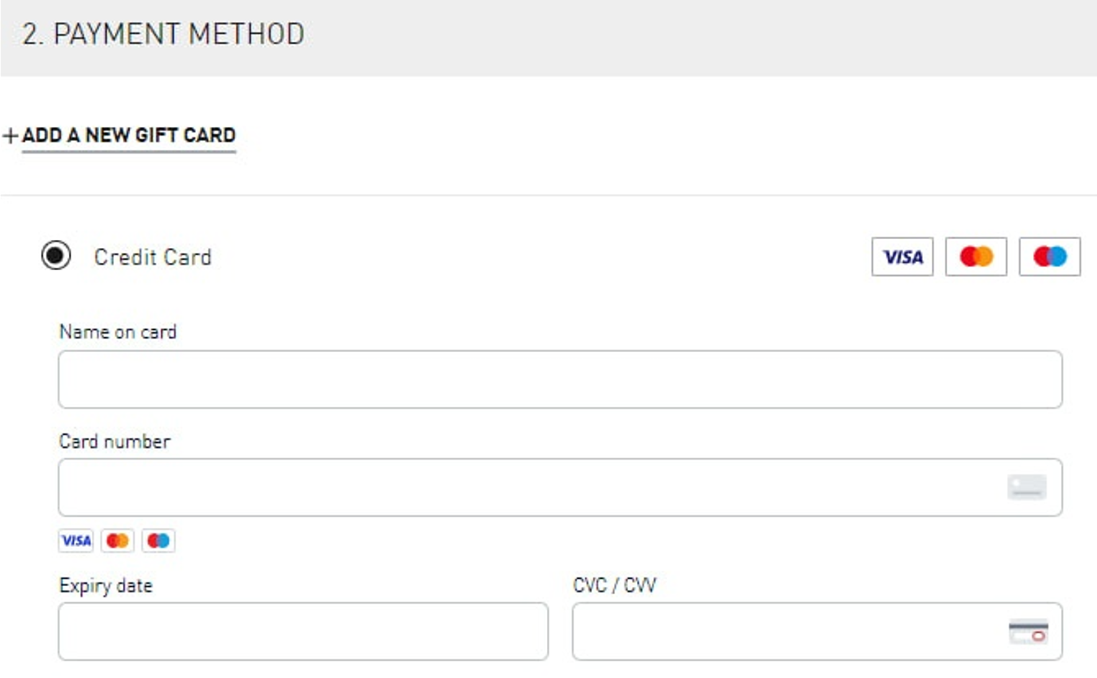

**Bag Item:**

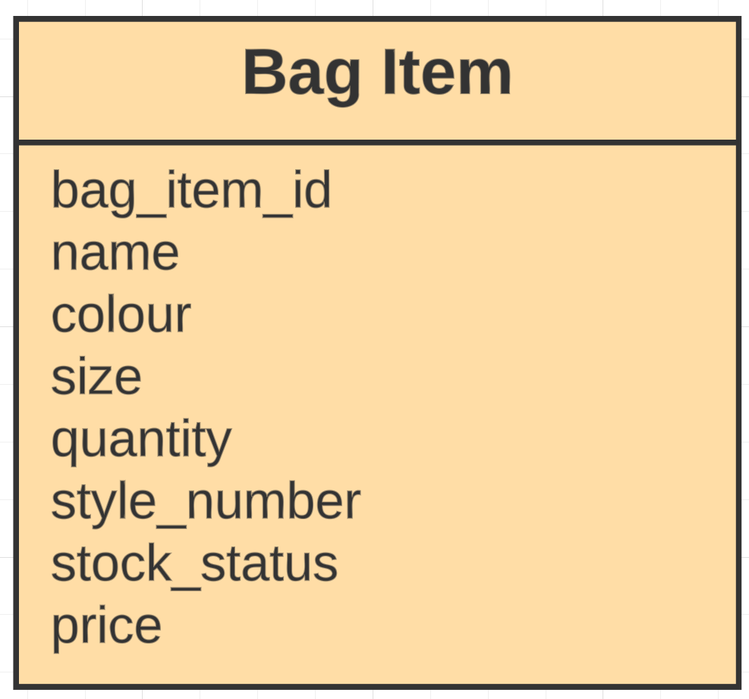

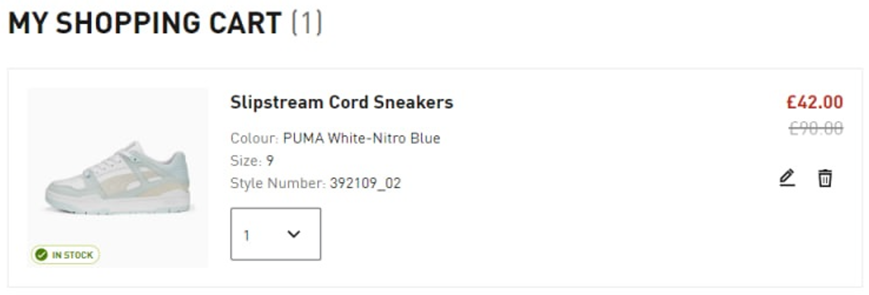

**Wishlist Item:**

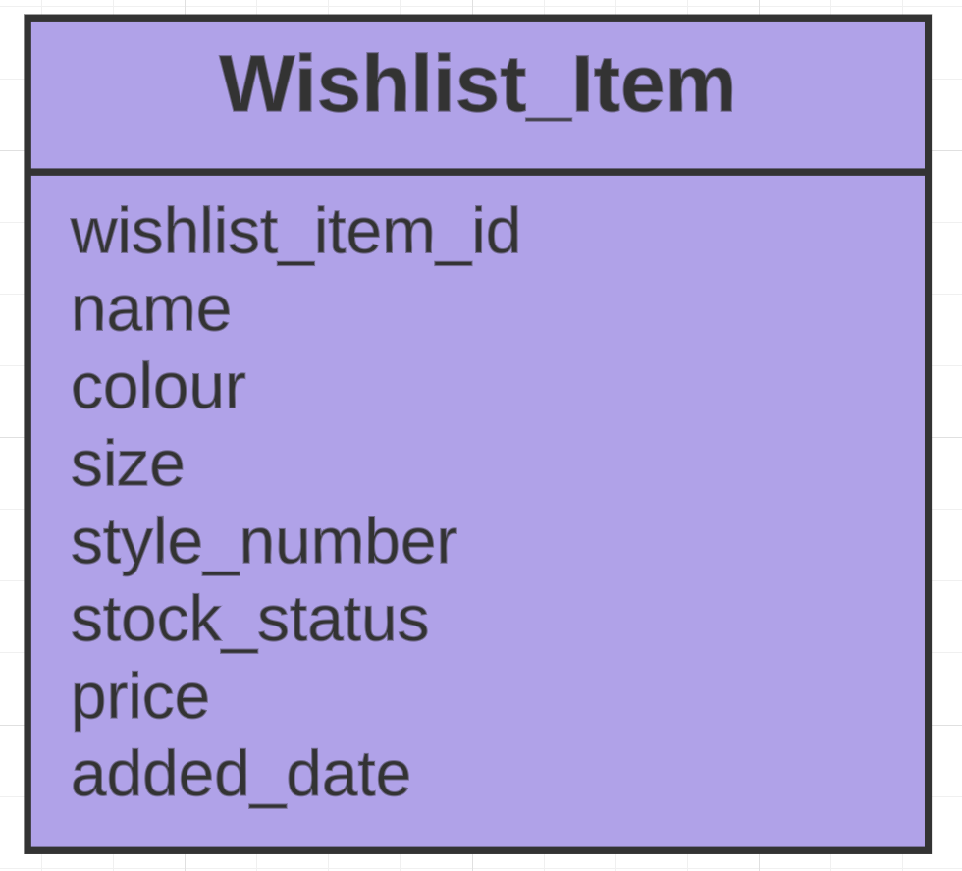

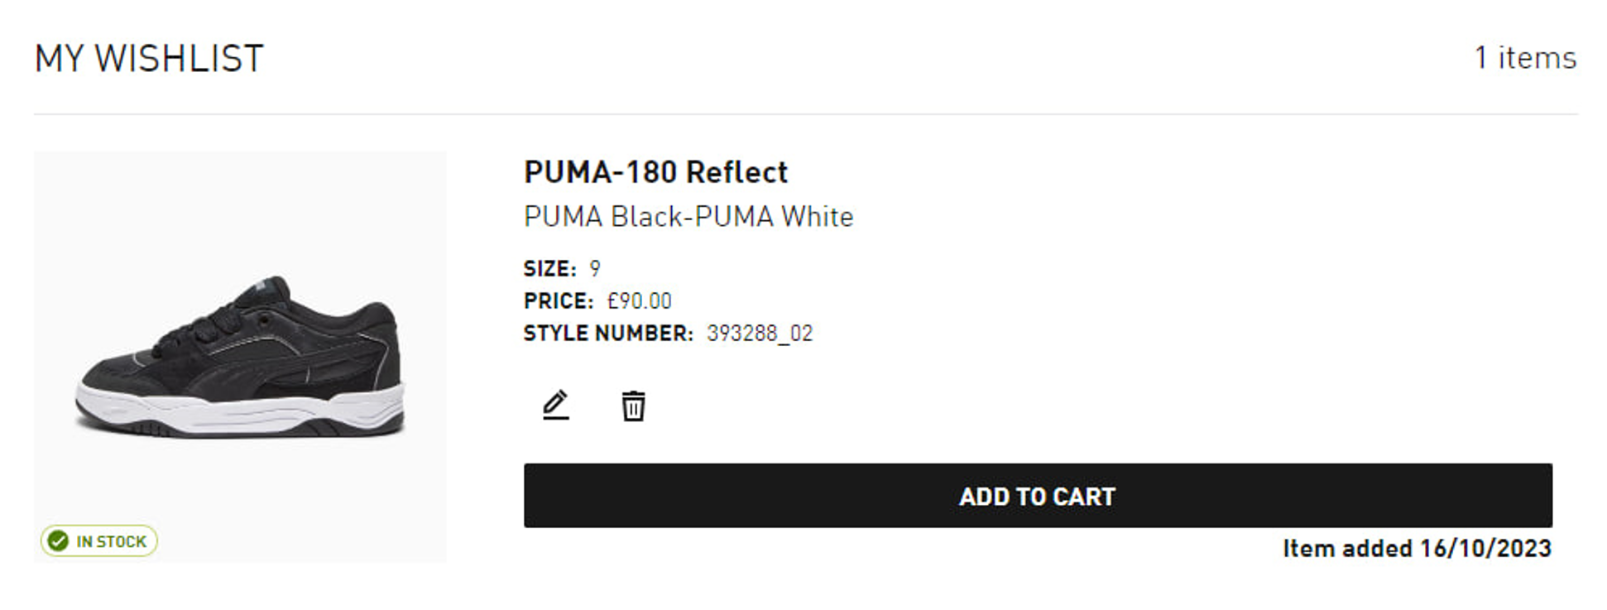

**Order:**



**Product:**

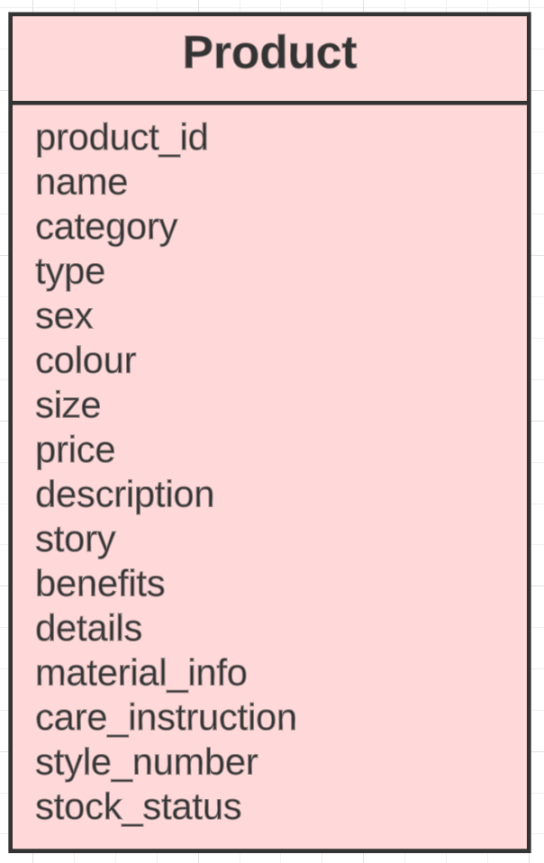

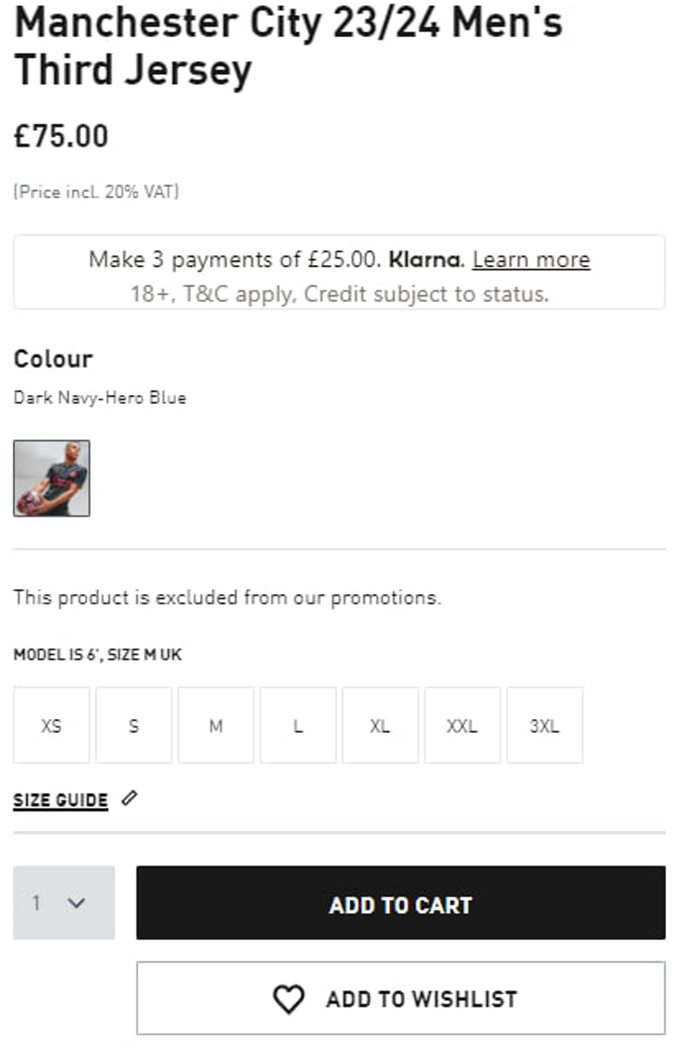

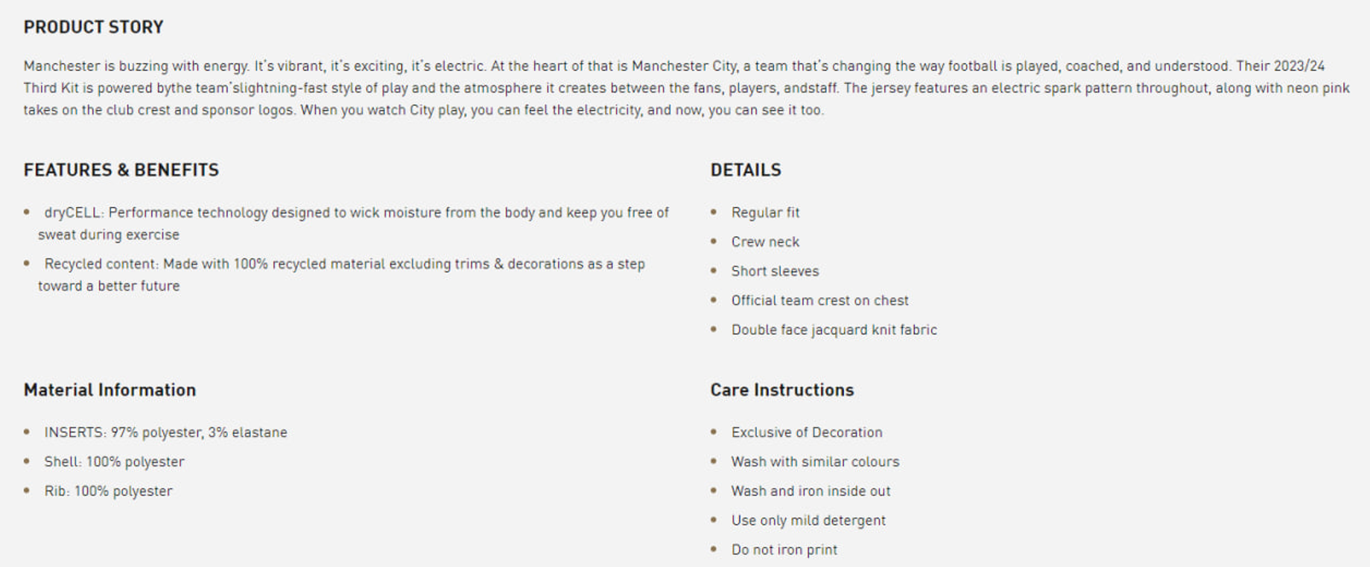

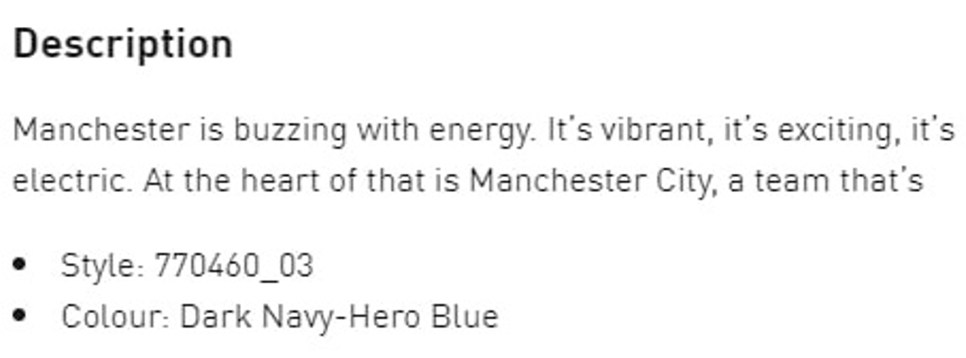

## **Generic List**

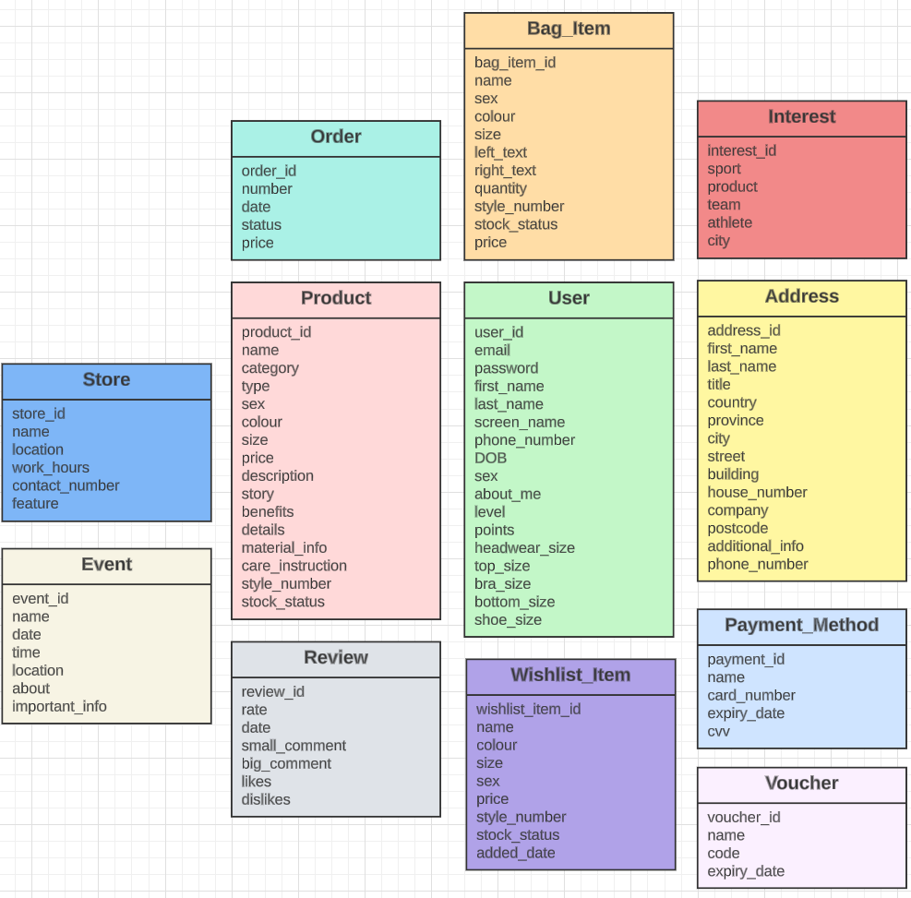

This is my generic list where you can see all the different entities and attributes from the Nike, Adidas and Puma websites. The common entities between these 3 websites are: User, Address, Payment Method, Bag, Wishlist, Product and Order. New entities: Interest and Event from Nike website, Voucher from Adidas website. Store and Review entities from Nike and Adidas.

# **Design**

## **Entity Relationship Diagram**

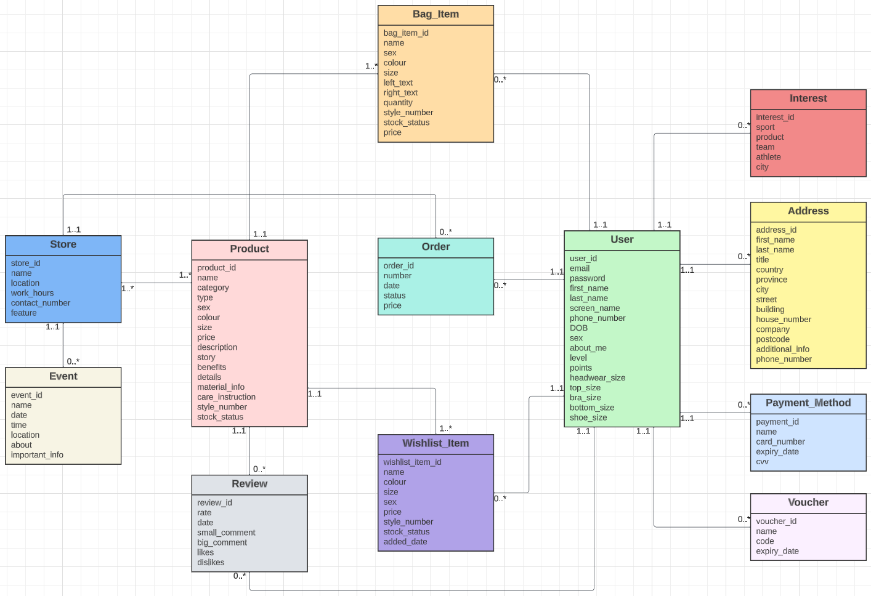

Here you can see a simple version of how my entities from the generic list are related to each other. This diagram does not contain extended features like extended attributes or extended relationships. However, all these things will be provided in the extended version of this diagram. In this picture you can just see how entities are connected and what their cardinality are.

## **Extended Entity Relationship Diagram**

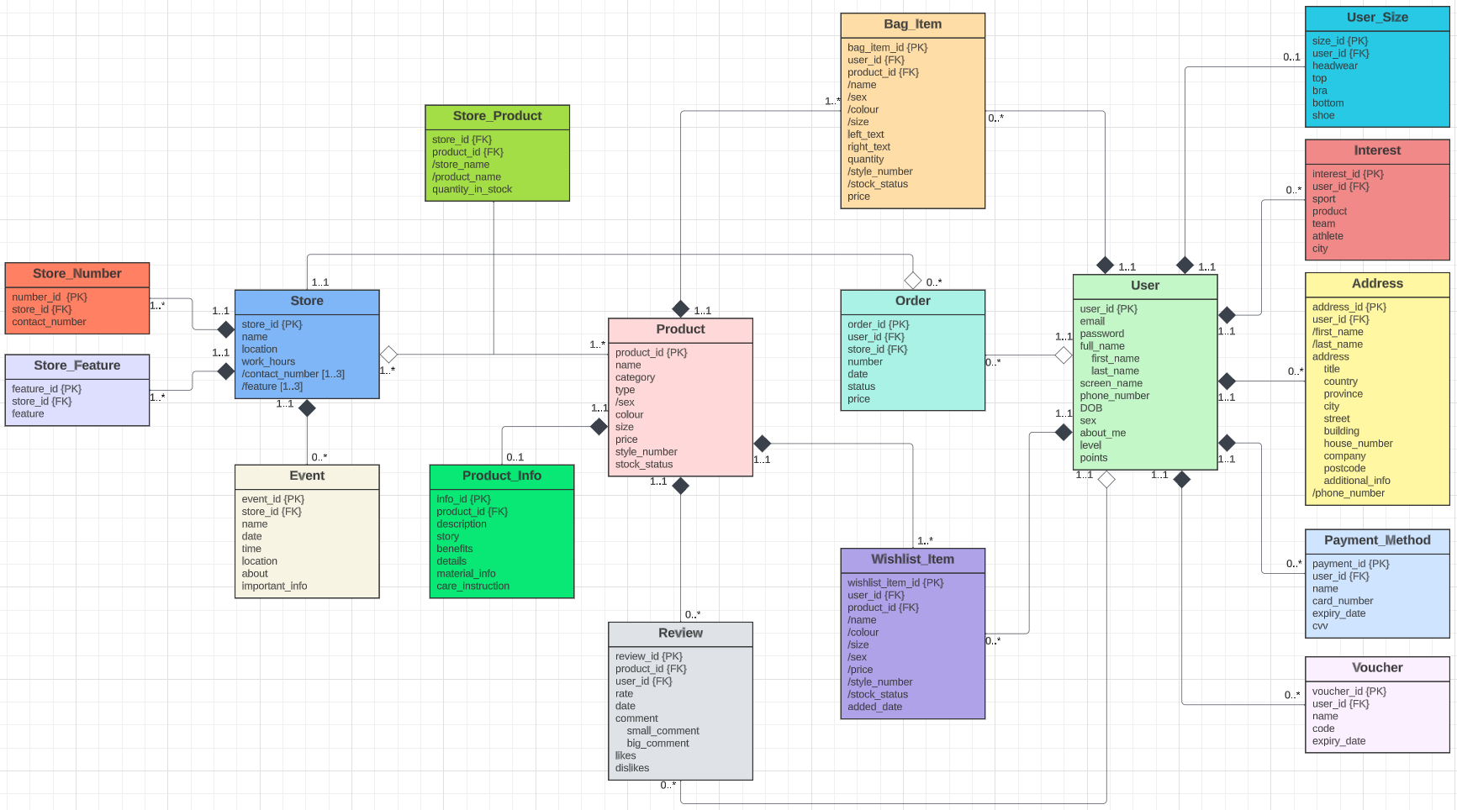

This is my extended version of ERD. After considering cardinality between different entities it was decided to expand the diagram with new entities. For example, Store and Product have one to many relationship from each side, this means that we need to create a new entity that we can call “Store Product”.

Also, it’s not good practice to store a lot of data in just one table, so I divided the “User” entity in two tables called “User” and “User Size”. I did the same principle with the “Product” entity, divided into “Product” and “Product Info”. This way, my database will look much better.

As you can see each entity has its own Primary Key that is indicated by {PK} near the main attribute. Attributes which are Foreign Key indicated as {FK}.

The “Store” entity was enhanced into “Store Number” and “Store Feature” because the “Store” entity contains multiple attributes such as contact number and feature. Using these attributes you can insert multiple values, so I split this entity into separate ones.

Composite and derived attributes were added to this diagram. Composite attributes: full name (User), address (Address), comment (Review). Derived attributes: first name, last name, phone number (Address), name, sex, colour, size, style number, stock number (Bag Item and Wishlist Item), store name, product name (Store Product), contact number, feature (Store). A lot of attributes were derived with the purpose of Normalisation.

Extended relationships were also added to this diagram. Such entities as “User Size”, “Interest”, “Address”, “Payment Method”, “Voucher”, “Bag Item” and “Wishlist Item” will be deleted if “User” entity had been deleted, so that’s why I use here composition relationship. “User” has an aggregation relationship with the “Order” entity, because if we delete users, order will still exist.

## **Normalised Model**

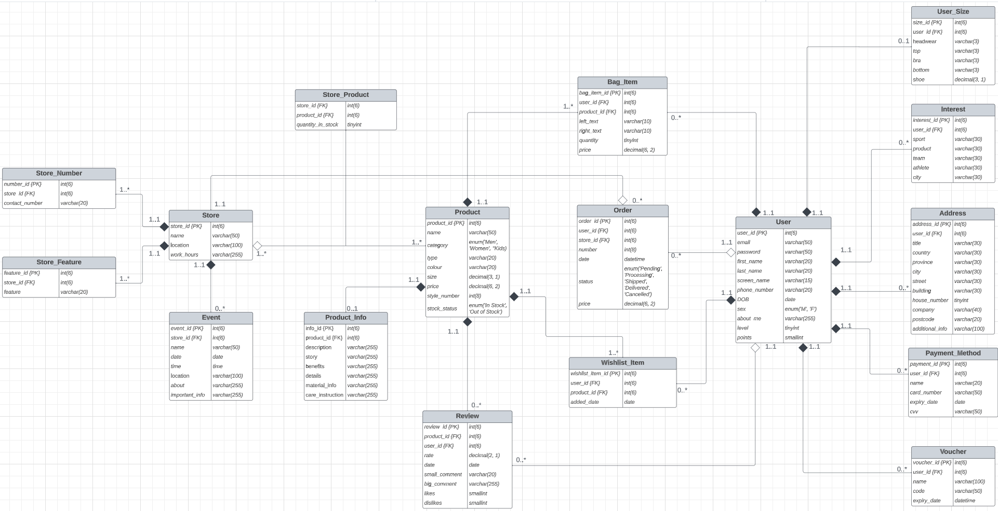

The database has successfully passed the first normal form. Because each attribute in my tables can contain only one value. Also, each table contains a primary key.

The database has successfully passed the second normal form. Because it’s already in the first normal form and there are no attributes which require only one part of the key to identify them uniquely.

The database has successfully passed the third normal form. Because it’s already in first normal form and second normal form. Also, there are no non-key attributes that depend on any other non-key attributes.

## **Database Scheme**

|  |  |  |
| --- | --- | --- |
| **User** | | |
| **Attribute** | **Type** | **Description** |
| user_id | int(6) | Primary Key. Holds a unique number for each user. |
| email | varchar(50) | Holds user’s email. |
| password | varchar(50) | Holds user’s password. |
| first_name | varchar(20) | Holds user’s first name. |
| last_name | varchar(20) | Holds user’s last name. |
| screen_name | varchar(15) | Holds user’s screen name. |
| phone_number | varchar(20) | Holds user’s phone number. Here I use varchar instead of int data type, because phone numbers include the “+” symbol. |
| DOB | date | Holds user’s date of birth. |
| sex | enum(‘M’, ‘F’) | Holds user’s gender. M – Male, F – Female. |
| about_me | varchar(255) | Holds user’s “about me” information. |
| level | tinyint | Holds user’s level. Here I use tinyint to store numbers up to 127. |
| points | smallint | Holds user’s points. Here I use tinyint to store numbers up to 32,767. |

|  |  |  |
| --- | --- | --- |
| **Address** | | |
| **Attribute** | **Type** | **Description** |
| address_id | int(6) | Primary Key. Holds a unique number for each user. |
| user_id | int(6) | Foreign Key. Holds a unique number with the help of which we can produce “Join” operations. |
| title | varchar(30) | Holds user’s title name of the address. |
| country | varchar(30) | Holds user’s country name of the address. |
| province | varchar(30) | Holds user’s province name of the address. |
| city | varchar(30) | Holds user’s city name of the address. |
| street | varchar(30) | Holds user’s street name of the address. |
| building | varchar(30) | Holds user’s building name of the address. |
| house_number | tinyint | Holds user’s house number of the address. |
| company | varchar(40) | Holds user’s company name of the address. |
| postcode | varchar(20) | Holds user’s postcode of the address. Using varchar because I don’t know exactly the number of chars. All countries have different postcodes. |
| additional_info | varchar(100) | Holds user’s additional info. |

|  |  |  |
| --- | --- | --- |
| **Payment_Method** | | |
| **Attribute name** | **Type** | **Description** |
| payment_id | int(6) | Primary Key. Holds a unique number for each user. |
| user_id | int(6) | Foreign Key. Holds a unique number with the help of which we can produce “Join” operations. |
| name | varchar(20) | Holds user’s name of the payment method. |
| card_number | varchar(50) | Holds card number. Using varchar because data will be hashed. |
| expiry_date | date | Holds card expiry date. |
| cvv | varchar(50) | Hold user’s cvv of the card. Using varchar because data will be hashed. |

|  |  |  |
| --- | --- | --- |
| **Bag_item** | | |
| **Attribute name** | **Type** | **Description** |
| bag_item_id | int(6) | Primary Key. Holds a unique number for each user. |
| user_id | int(6) | Foreign Key. Holds a unique number with the help of which we can produce “Join” operations. |
| product_id | int(6) | Foreign Key. Holds a unique number with the help of which we can produce “Join” operations. |
| left_text | varchar(10) | Holds the left text of bag item. |
| right_text | varchar(10) | Holds the right text of bag item. |
| quantity | tinyint | Holds a quantity of bag item. |
| price | decimal(6, 2) | Holds the price of bag item. Here I use a decimal data type because price can be float. |

|  |  |  |
| --- | --- | --- |
| **Wishlist_item** | | |
| **Attribute name** | **Type** | **Description** |
| wishlist_  item_id | int(6) | Primary Key. Holds a unique number for each user. |
| user_id | int(6) | Foreign Key. Holds a unique number with the help of which we can produce “Join” operations. |
| product_id | int(6) | Foreign Key. Holds a unique number with the help of which we can produce “Join” operations. |
| added_date | date | Holds the date which indicates when user added the item to the wishlist. |

|  |  |  |
| --- | --- | --- |
| **Product** | | |
| **Attribute name** | **Type** | **Description** |
| product_id | int(6) | Primary Key. Holds a unique number for each user. |
| name | varchar(50) | Holds product’s name. |
| category | enum('Men', 'Women', ''Kids) | Holds product’s category. |
| type | varchar(20) | Holds product’s type. |
| colour | varchar(20) | Holds product’s colour. |
| size | decimal(3, 1) | Holds product’s size. Size can be float, so I decided to use a decimal data type. |
| price | decimal (6, 2) | Holds product’s price. Can be float, so I decided to use a decimal data type. |
| style_number | int(8) | Holds product’s style number. |
| stock_status | enum('In Stock', 'Out of Stock') | Holds product’s stock status. |

|  |  |  |
| --- | --- | --- |
| **Order** | | |
| **Attribute name** | **Type** | **Description** |
| order_id | int(6) | Primary Key. Holds a unique number for each user. |
| user_id | int(6) | Foreign Key. Holds a unique number with the help of which we can produce “Join” operations. |
| store_id | int(6) | Foreign Key. Holds a unique number with the help of which we can produce “Join” operations. |
| number | int(8) | Holds order’s number. |
| date | datetime | Holds order’s date. Here I use datetime data type instead of date, because I also want to see the exact time. |
| status | enum('Pending', 'Processing', 'Shipped', 'Delivered', 'Cancelled') | Holds order’s status. |
| price | decimal(6, 2) | Holds order’s price. Can be float, so I decided to use a decimal data type. |

|  |  |  |
| --- | --- | --- |
| **Review** | | |
| **Attribute name** | **Type** | **Description** |
| review_id | int(6) | Primary Key. Holds a unique number for each user. |
| product_id | int(6) | Foreign Key. Holds a unique number with the help of which we can produce “Join” operations. |
| user_id | int(6) | Foreign Key. Holds a unique number with the help of which we can produce “Join” operations. |
| rate | decimal(2, 1) | Holds review’s rate. Can be float, so I decided to use decimal data type. |
| date | date | Holds review’s date. |
| small_comment | varchar(20) | Holds review’s small comment. |
| big_comment | varchar(255) | Holds review’s big comment. |
| likes | smallint | Holds review’s number of likes. |
| dislikes | smallint | Holds review’s number of dislikes. |

|  |  |  |
| --- | --- | --- |
| **Store** | | |
| **Attribute name** | **Type** | **Description** |
| store_id | int(6) | Primary Key. Holds a unique number for each user. |
| name | varchar(50) | Holds store’s name. |
| location | varchar(100) | Holds store’s location. |
| work_hours | varchar(255) | Holds store’s work hours. |

|  |  |  |
| --- | --- | --- |
| **Event** | | |
| **Attribute name** | **Type** | **Description** |
| event_id | int(6) | Primary Key. Holds a unique number for each user. |
| store_id | int(6) | Foreign Key. Holds a unique number with the help of which we can produce “Join” operations. |
| name | varchar(50) | Holds event’s name. |
| date | date | Holds event’s date. |
| time | time | Holds event’s time. |
| location | varchar(100) | Holds event’s location. |
| about | varchar(255) | Holds event’s about section. |
| important_info | varchar(255) | Holds event’s important info. |

|  |  |  |
| --- | --- | --- |
| **Voucher** | | |
| **Attribute name** | **Type** | **Description** |
| voucher_id | int(6) | Primary Key. Holds a unique number for each user. |
| user_id | int(6) | Foreign Key. Holds a unique number with the help of which we can produce “Join” operations. |
| name | varchar(100) | Holds voucher’s name. |
| code | varchar(50) | Holds voucher’s code. Using varchar because data will be hashed. |
| expiry_date | datetime | Holds voucher’s expiry date. |

|  |  |  |
| --- | --- | --- |
| **User_Size** | | |
| **Attribute name** | **Type** | **Description** |
| size_id | int(6) | Primary Key. Holds a unique number for each user. |
| user_id | int(6) | Foreign Key. Holds a unique number with the help of which we can produce “Join” operations. |
| headwear | varchar(3) | Holds user’s size of the headwear. |
| top | varchar(3) | Holds user’s size of the top. |
| bra | varchar(3) | Holds user’s size of the bra. |
| bottom | varchar(3) | Holds user’s size of the bottom. |
| shoe | decimal(3, 1) | Holds user’s size of the shoe. Can be float, so I decided to use decimal data type. |

|  |  |  |
| --- | --- | --- |
| **Interest** | | |
| **Attribute name** | **Type** | **Description** |
| interest_id | int(6) | Primary Key. Holds a unique number for each user. |
| user_id | int(6) | Foreign Key. Holds a unique number with the help of which we can produce “Join” operations. |
| sport | varchar(30) | Holds sport’s name. |
| product | varchar(30) | Holds product’s name. |
| team | varchar(30) | Holds team’s name. |
| athlete | varchar(30) | Holds athlete’s name. |
| city | varchar(30) | Holds city’s name. |

|  |  |  |
| --- | --- | --- |
| **Product_Info** | | |
| **Attribute name** | **Type** | **Description** |
| info_id | int(6) | Primary Key. Holds a unique number for each user. |
| product_id | int(6) | Foreign Key. Holds a unique number with the help of which we can produce “Join” operations. |
| description | varchar(255) | Holds product’s description. |
| story | varchar(255) | Holds product’s story. |
| benefits | varchar(255) | Holds product’s benefits. |
| details | varchar(255) | Holds product’s details. |
| material_info | varchar(255) | Holds product’s material info. |
| care_instruction | varchar(255) | Holds product’s care instruction. |

|  |  |  |
| --- | --- | --- |
| **Store_Product** | | |
| **Attribute name** | **Type** | **Description** |
| store_id | int(6) | Foreign Key. Holds a unique number with the help of which we can produce “Join” operations. |
| product_id | int(6) | Foreign Key. Holds a unique number with the help of which we can produce “Join” operations. |
| quantity_in_stock | tinyint | Holds product’s quantity in stock. |

|  |  |  |
| --- | --- | --- |
| **Store_Number** | | |
| **Attribute name** | **Type** | **Description** |
| number_id | int(6) | Primary Key. Holds a unique number for each user. |
| store_id | int(6) | Foreign Key. Holds a unique number with the help of which we can produce “Join” operations. |
| contact_number | varchar(20) | Holds store’s number. |

|  |  |  |
| --- | --- | --- |
| **Store_Feature** | | |
| **Attribute name** | **Type** | **Description** |
| feature_id | int(6) | Primary Key. Holds a unique number for each user. |
| store_id | int(6) | Foreign Key. Holds a unique number with the help of which we can produce “Join” operations. |
| feature | varchar(20) | Holds store’s feature. |

# **Implementation**

In this section I will provide screenshots of my implementation. The implementation will be done in MySQL Workbench because for me it’s much easier.

Each of the tables will be provided with ‘CREATE’ and ‘INSERT’ statements. Some of the data that was inserted is not real. Most of the data that was inserted is just for testing purposes.

Each table will be presented on the new page with the purpose of readability.

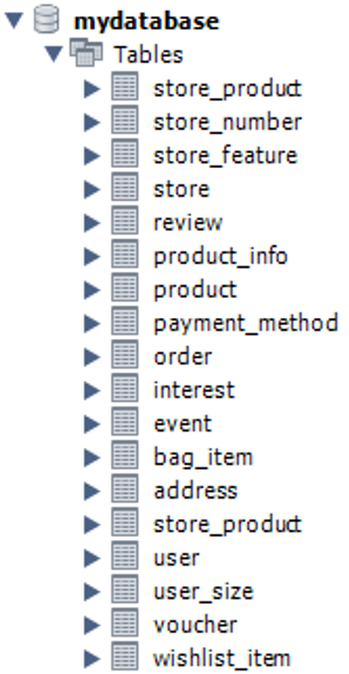

On this screenshot you can see all of my tables from the Normalised Model.

User

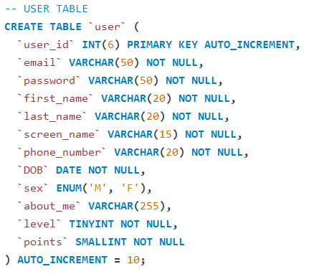

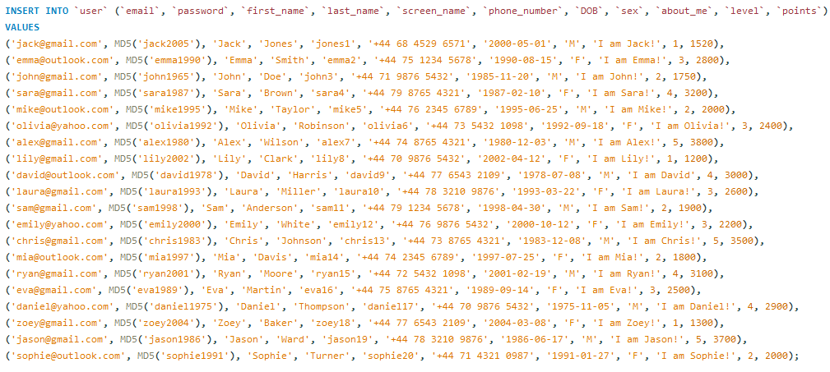

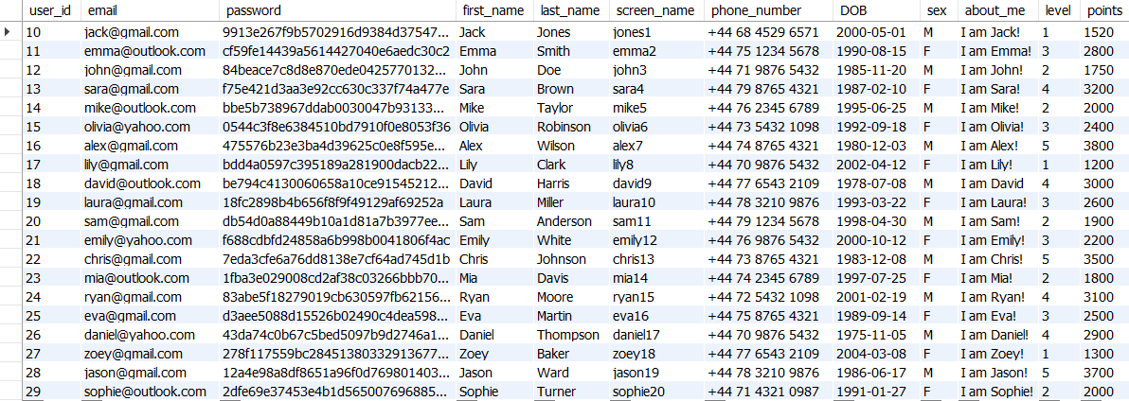

Address

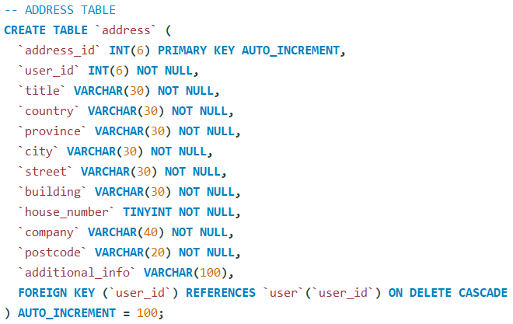

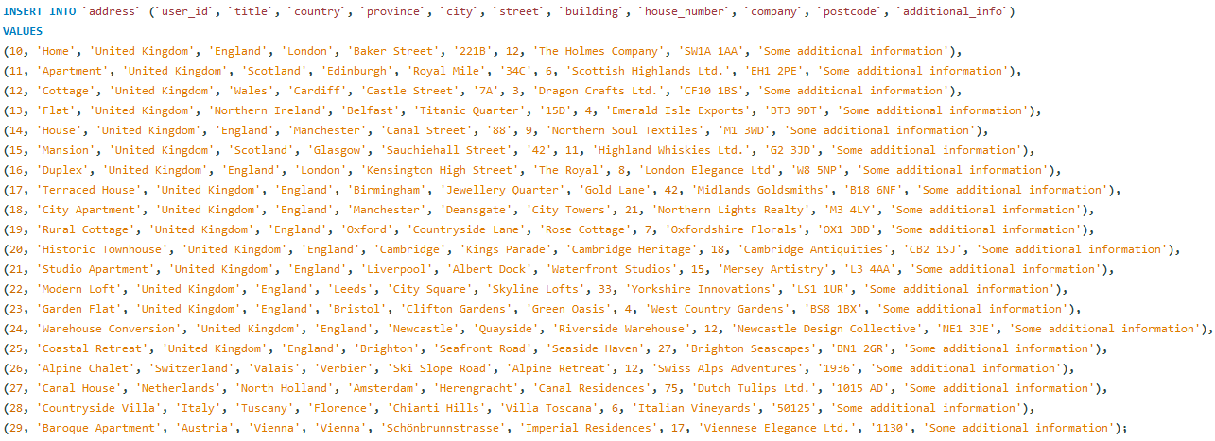

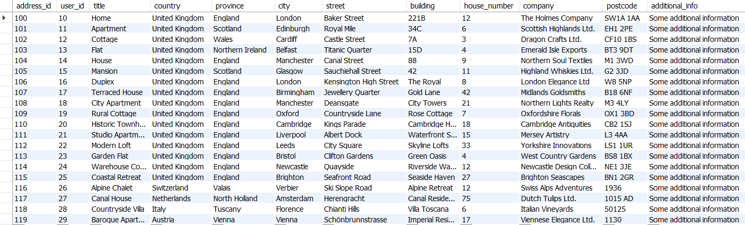

Payment Method

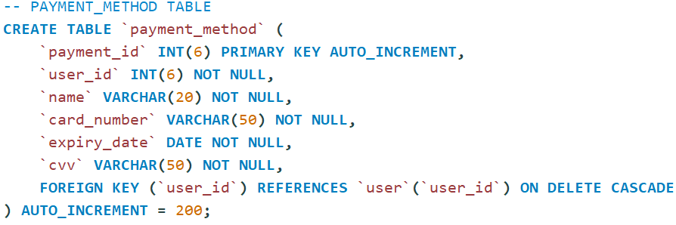

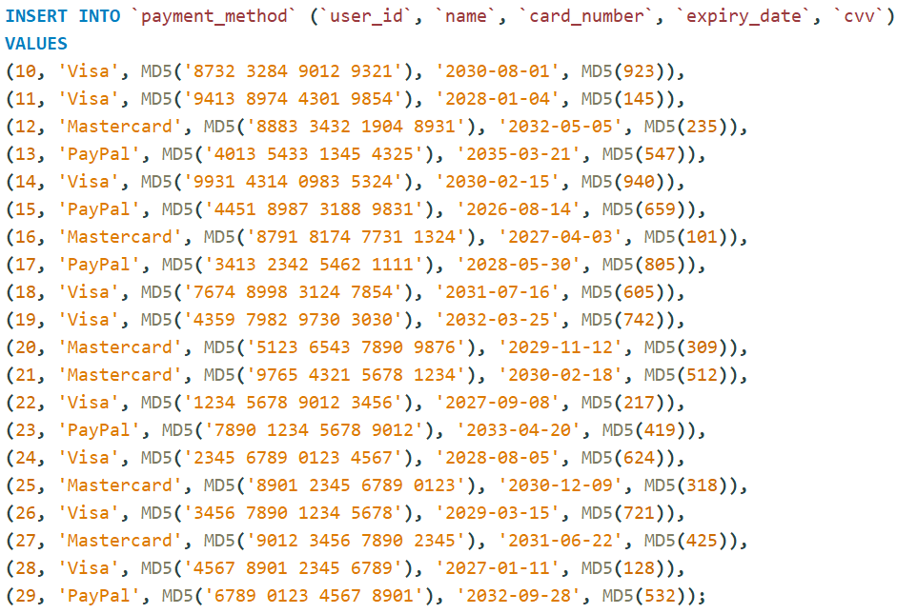

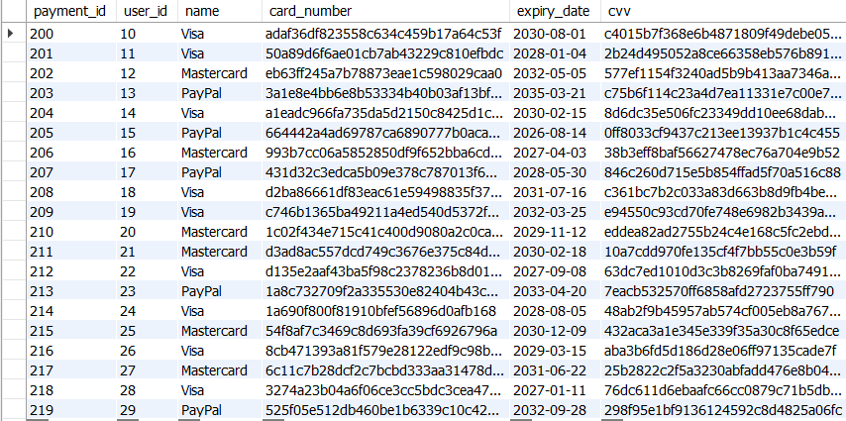

Voucher

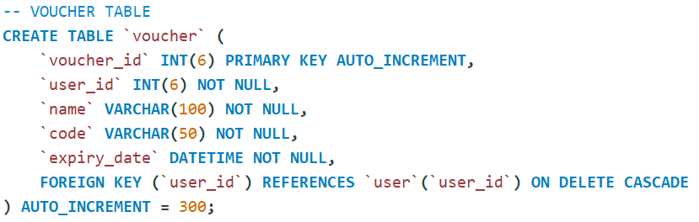

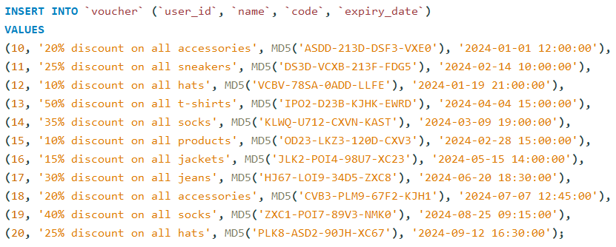

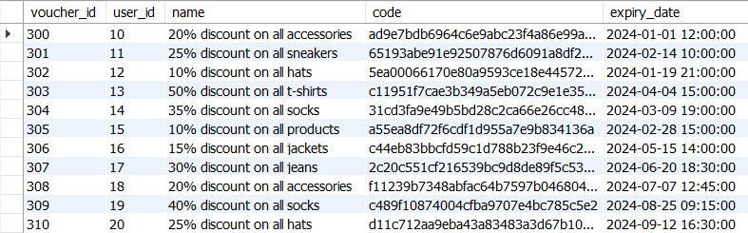

Interest

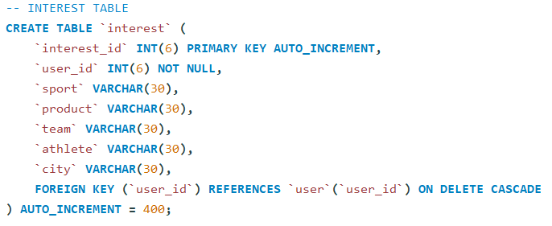

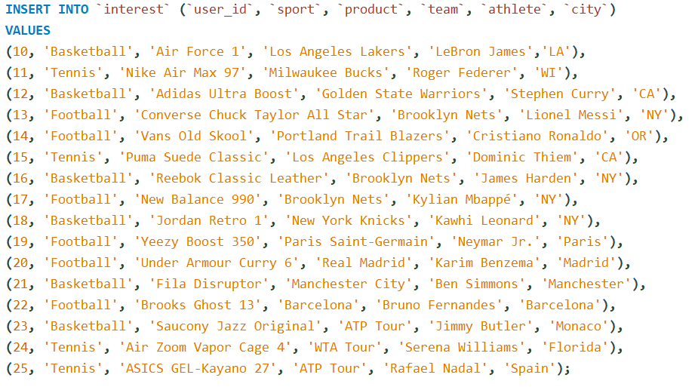

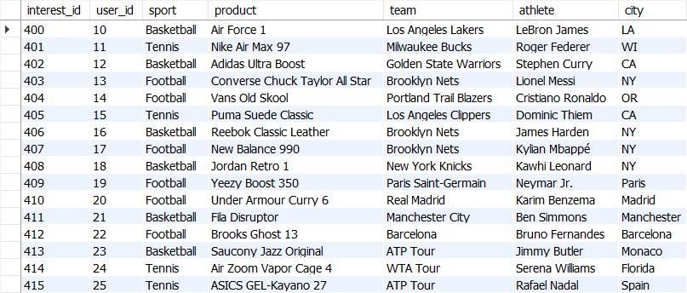

User Size

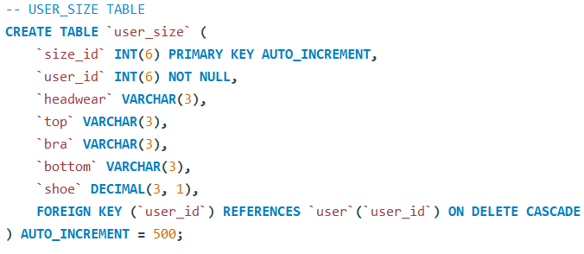

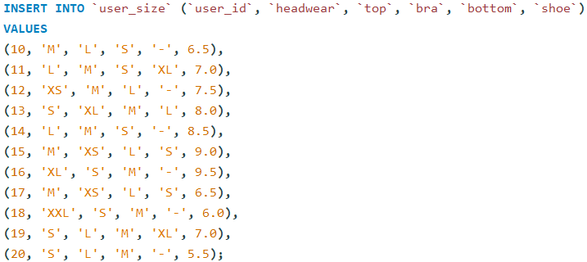

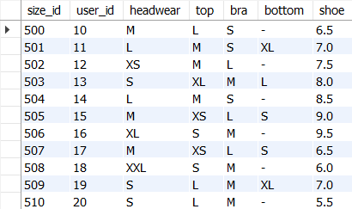

Product

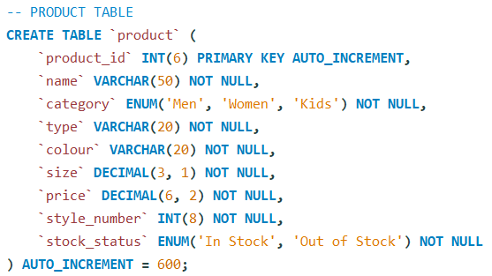

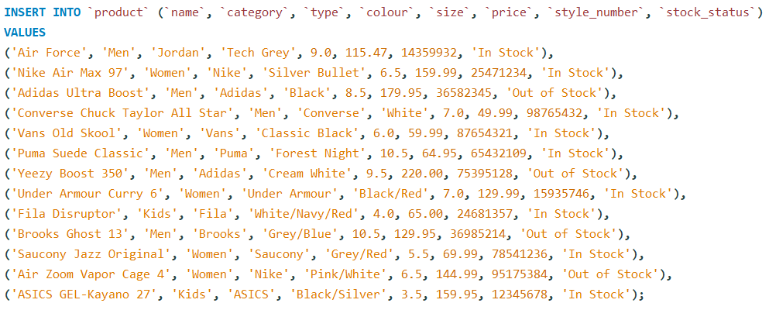

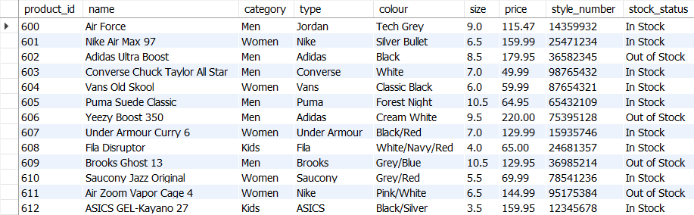

Bag Item

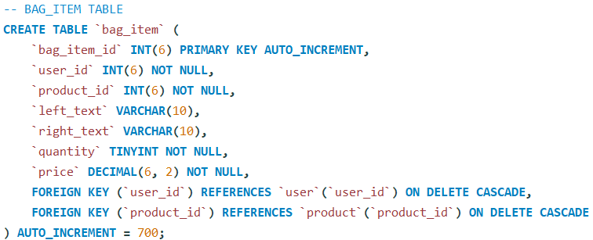

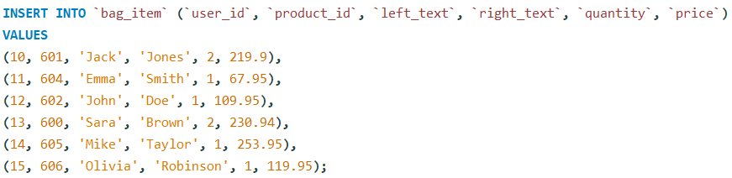

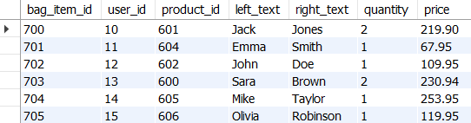

Wishlist Item

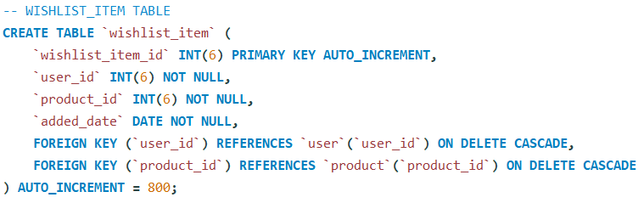

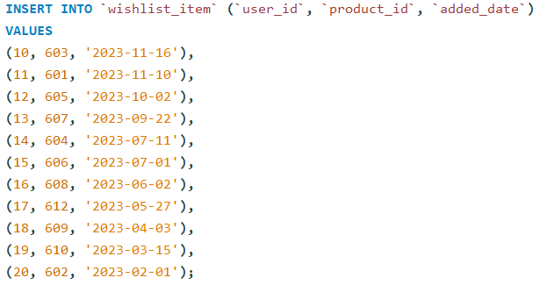

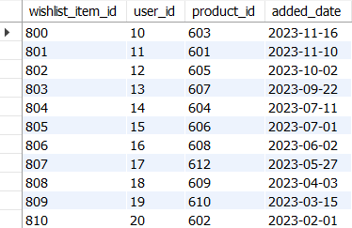

Store

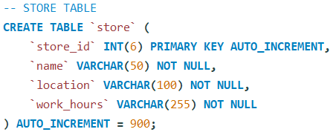

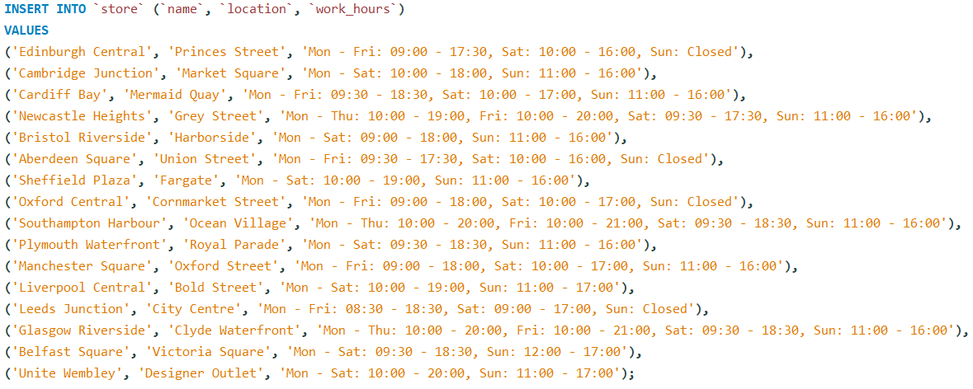

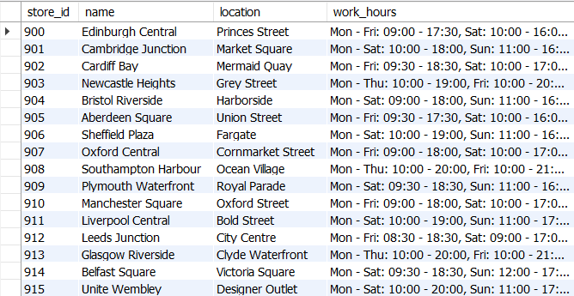

Event

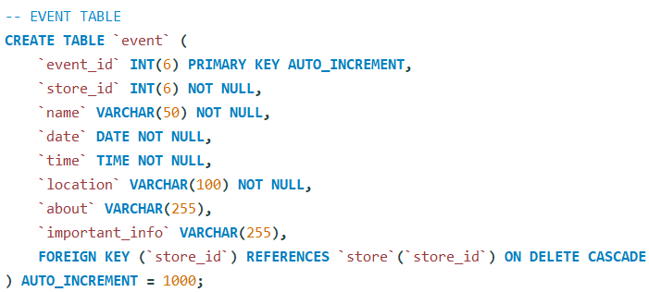

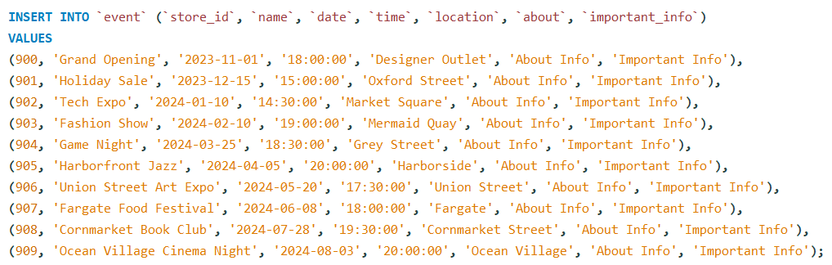

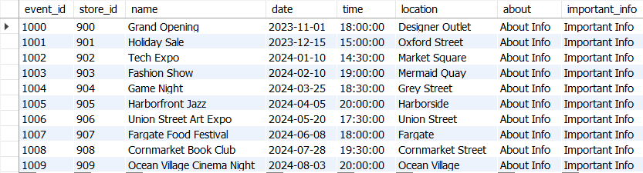

Order

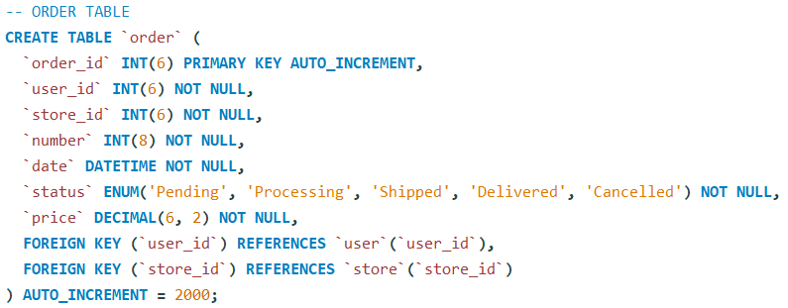

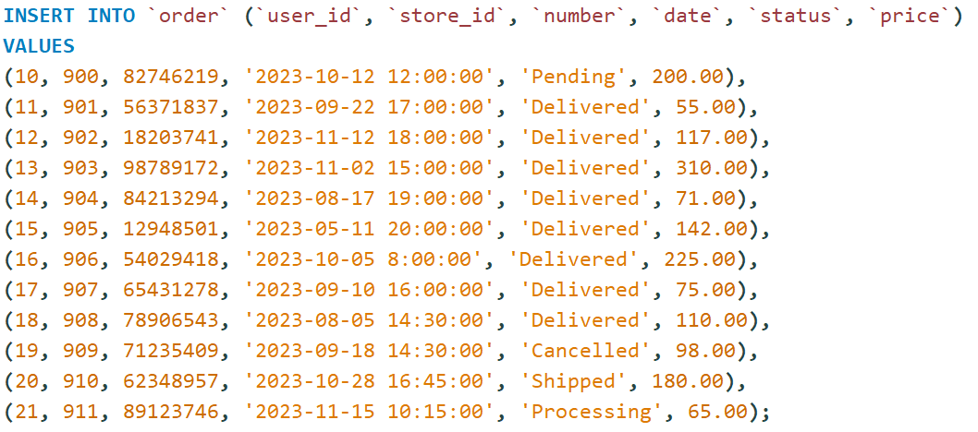

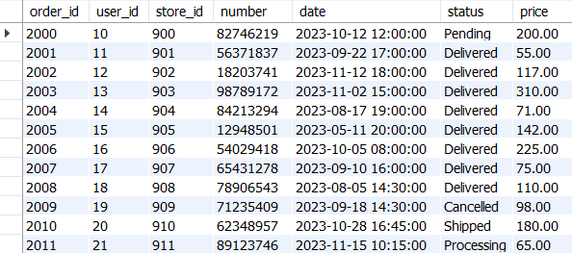

Review

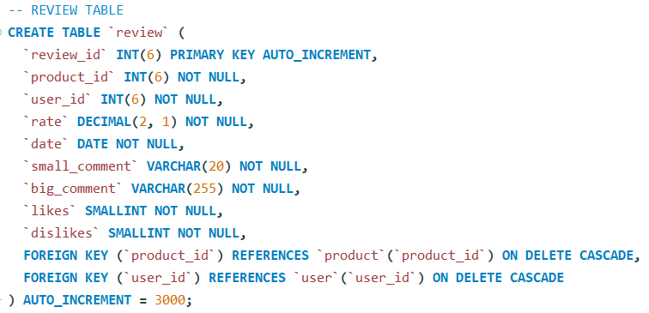

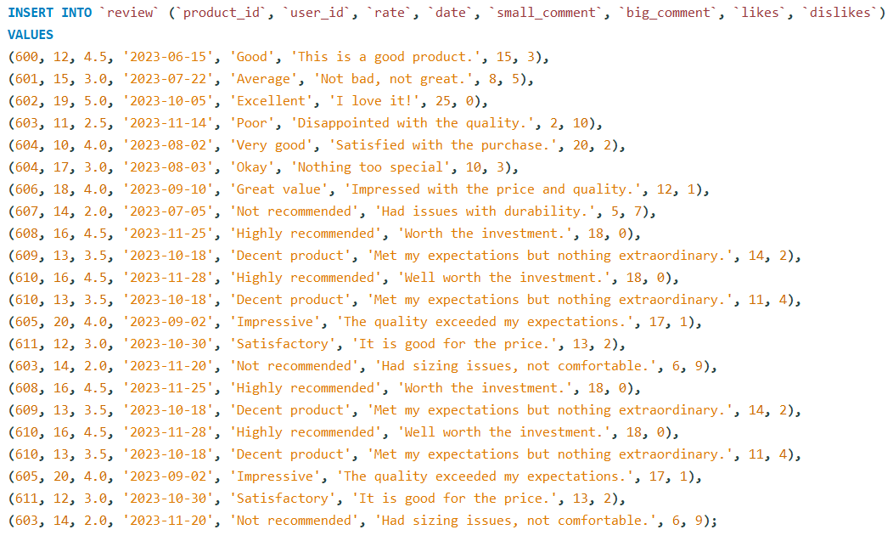

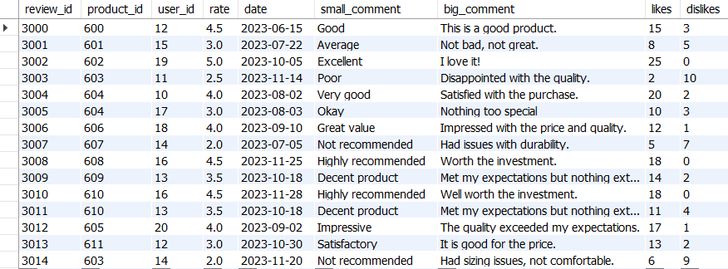

Product Info

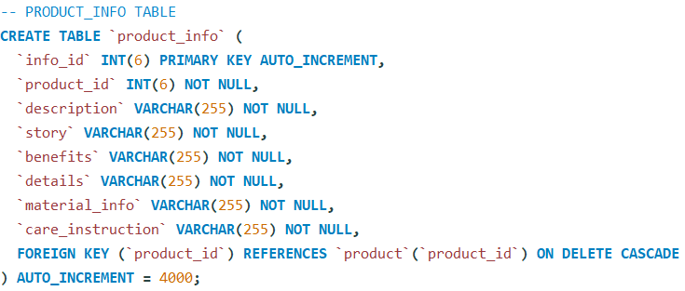

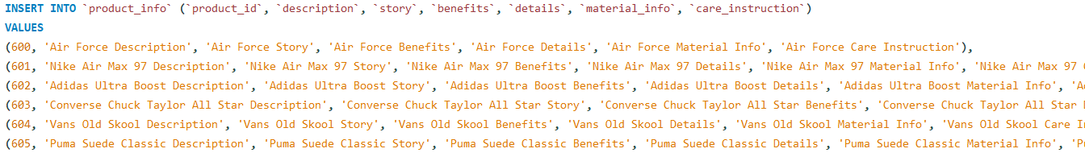

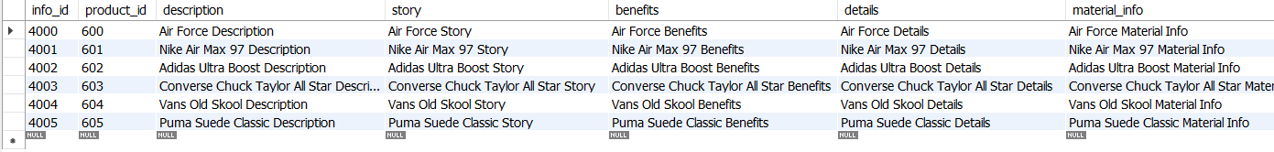

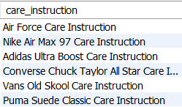

Store Product

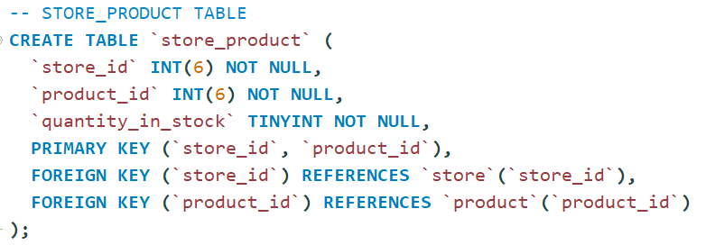

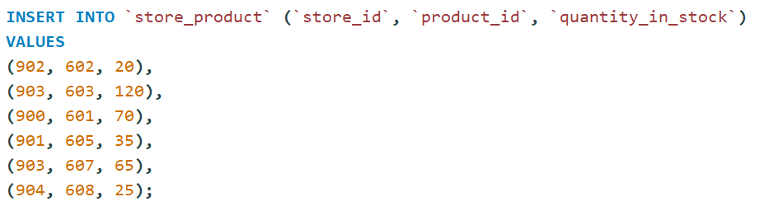

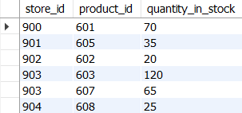

Store Number

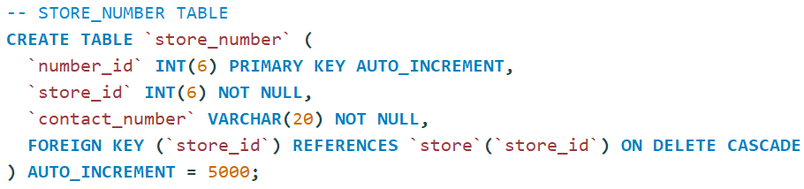

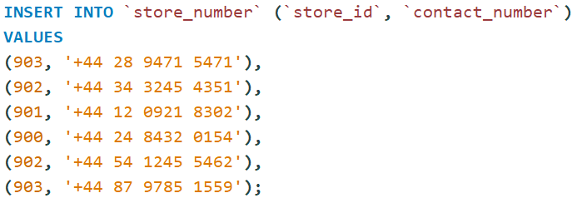

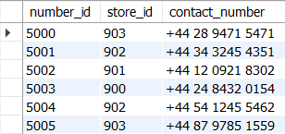

Store Feature

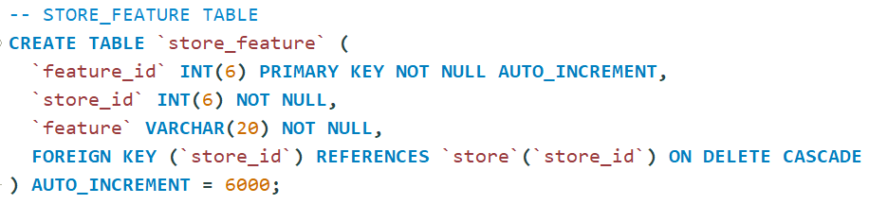

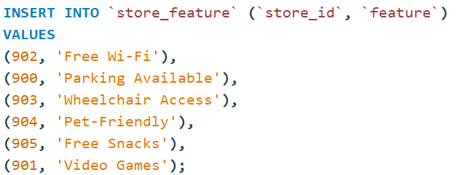

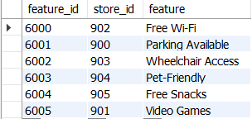

# **Testing**

## **Query 1**

### **Business purpose of the query**

With the help of this stored procedure, a person can search top-rated products based on average rating. Very useful query, that indicates which products people like more.

### **Query in natural language**

The Query shows product id, name, average rating and the total number of reviews for a particular product.

### **SQL Code and output**

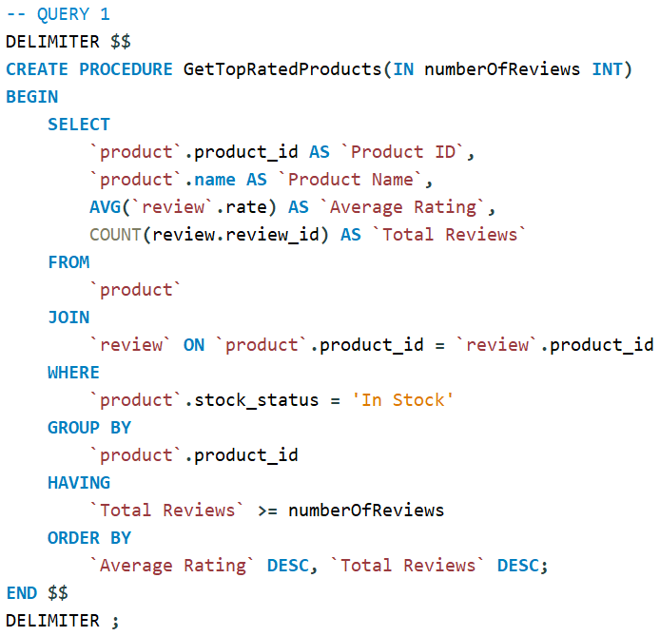

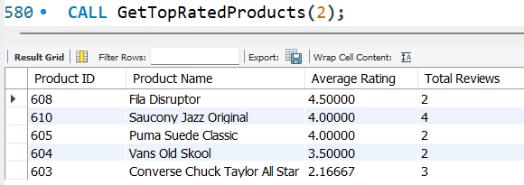

Minimum number of review = 2

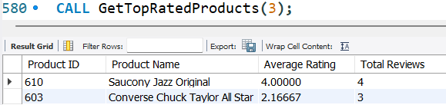

Minimum number of review = 3

### **Explanation of the query’s output**

Query shows the top-rated products based on average rating. It shows product id, name, average rating and total reviews. Also, It shows only in stock products. With the help of parameter, you can choose what is the minimum number of reviews of products that you want to display. In the first screenshot of the output I show only those products that have a minimum two reviews . In the second screenshot I show only those products that have a minimum three reviews. The output is grouped by product id and ordered by average rating and total reviews in descending order.

## **Query 2**

### **Business purpose of the query**

The purpose of the ‘GetUsersByCountryAndSport’ stored procedure is to retrieve information about user interest in sports in a specific country and count how many users are interested in a specific kind of sport. So, this query is very important for business because with the help of it, company can analyse which sport is attracting interest in different countries. For the e-commerce website that sells sneakers and sport accessories, this query is very useful.

### **Query in natural language**

The Query shows user id, full name, country and their interest in sport. Also, it shows how many users have the same sport interest.

### **SQL Code and output**

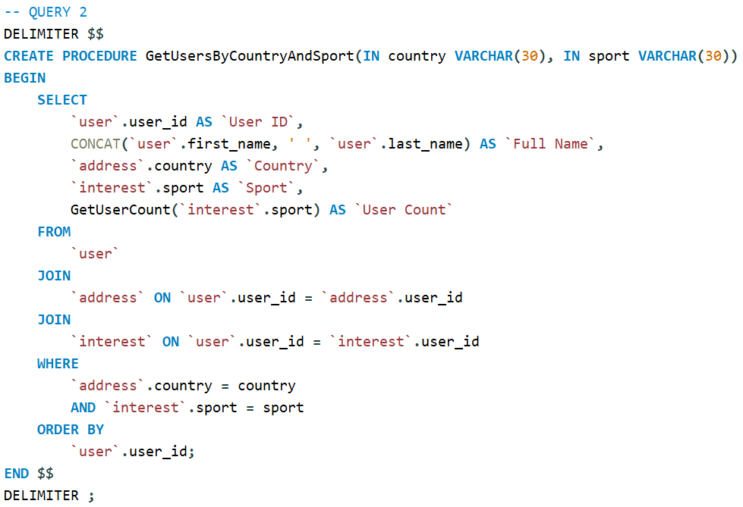

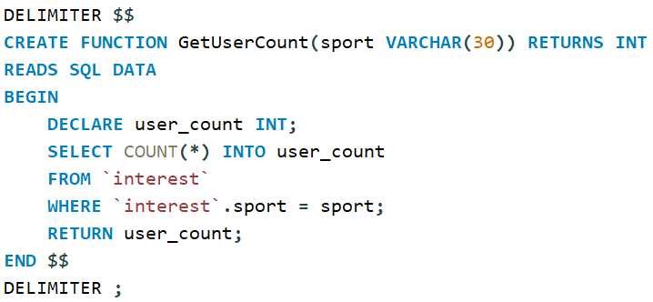

‘GetUserCount’ function

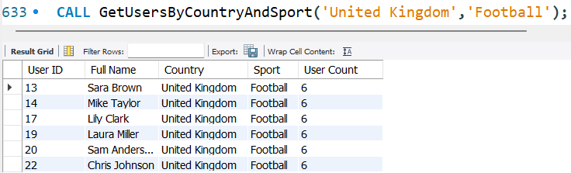

Output if we choose `Football` sport

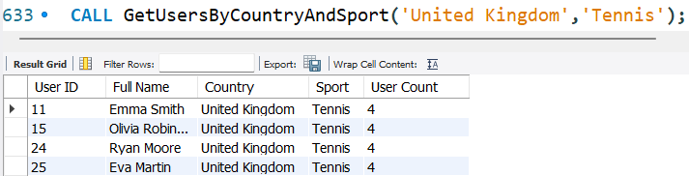

Output if we choose `Tennis` sport

### **Explanation of the query’s output**

This query displays users’ interest in specific kinds of sport. The ‘GetUserCount’ function calculates and returns the number of users interested in a particular sport based on the sport parameter. The first screenshot of the output demonstrates how many people are interested in Football. The second screenshot of the output demonstrates how many users are interested in Tennis. The output is ordered by user id.

## **Query 3**

### **Business purpose of the query**

This stored procedure, ‘GetRecentWishlistItems’, helps find the latest items that were added to a wishlist from a specific category (‘Men’, ‘Women’). Useful for understanding recent user preferences in that category for marketing decisions.

### **Query in natural language**

The Query shows user full names, product names, and added dates.

### **SQL Code and output**

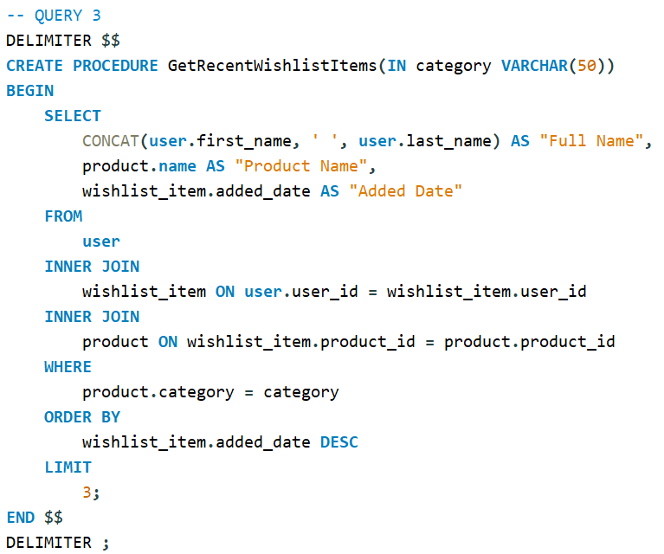

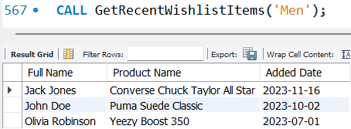

Output if category is ‘Men’

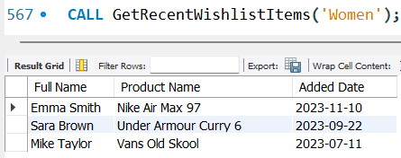

Output if category is ‘Women’

### **Explanation of the query’s output**

The query shows three latest wishlist items from a specific category, the buyer’s full name and the date when items were added to the wishlist. Firstly, I show the three latest wishlist items from the ‘Men’ category and then from the ‘Women’ category. The output is ordered by the added date in descending order. You can output as many items as you want by changing the LIMIT. In my case the LIMIT is set to 3 because I have a small database.

## **Query 4**

### **Business purpose of the query**

This stored procedure, ‘CalculateStoreSales’, calculates all sales for each store by summing the price of orders that have status ‘Delivered’. Very useful query in real life because the person who is in charge of the database can give the total amount of money that each store earned.

### **Query in natural language**

The Query shows store id, name, location and total sales for each store.

### **SQL Code and output**

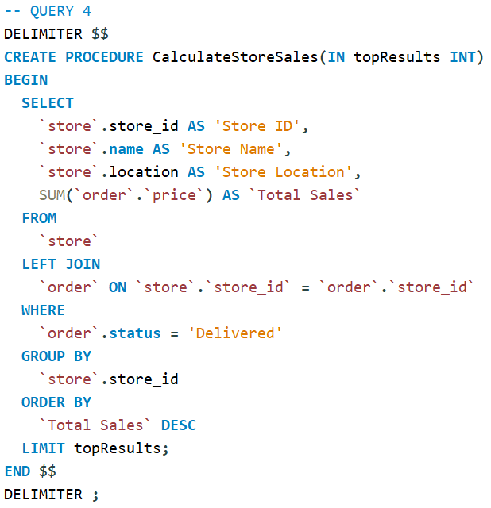

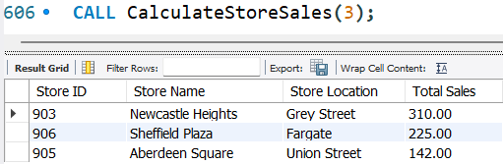

Top 3 stores

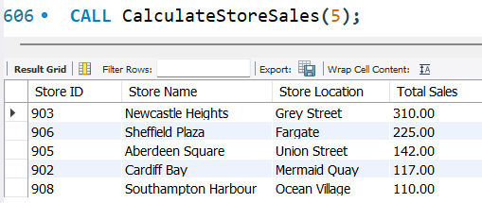

Top 5 stores

### **Explanation of the query’s output**

Basically, the query sums all orders for each store and displays the id of the store where the orders were proceeded, store name in which orders were processed, store location and total sales. Orders that have not been delivered were not included in calculation, because the user can cancel his order. With the help of parameter you can choose how many stores will output. For example, in the first screenshot I demonstrate the top three stores based on total sales. In the second screen you can see the top five stores. The output is grouped by store id because we have aggregate function and non-aggregated columns, so without GROUP BY clause the query would not work. Also, the output is ordered by total sales in descending order.

## **Query 5**

### **Business purpose of the query**

This is a very useful stored procedure called ‘AnalyseOrderStatistics’, which analyses who mostly purchase company products, men or female. With the help of this query, a company can see which gender is buying more products.

### **Query in natural language**

The Query shows the name of the gender, total number of orders that specific gender made and the total orders value.

### **SQL Code and output**

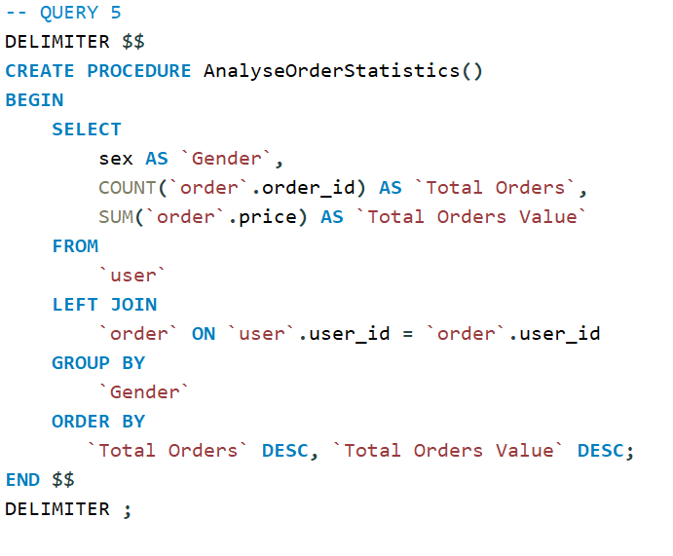

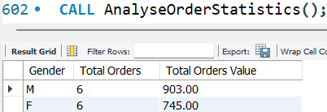

### **Explanation of the query’s output**

The output gives us a detailed analysis that shows which gender buys more products: ‘Men’ or ‘Women’. In my database, the number of orders is the same for both genders, which means that our business is popular among both men and women. However, as we can see, the total orders value is higher for men, which suggests that men buy more expensive products. The output is grouped by gender and ordered by total orders and total orders value.

# **References**

Nike Company (n.d.). *About Us*. Available at: <https://nikecompanyblog.wordpress.com/about-us/> (Accessed date: 15 October)

Lewis, R. (2023). *Adidas, History & Society*. Available at: <https://www.britannica.com/topic/Adidas-AG> (Accessed date: 21 October)

GlobalData (2023). *Puma SE: Overview*. Available at: <https://www.globaldata.com/company-profile/puma-se/> (Accessed date: 29 October)

Nike (2023). *Nike. Just Do It*. Available at: <https://www.nike.com/gb/> (Accessed date: 01 October)

Adidas (2023). *adidas® Official Website*. Available at: <https://www.adidas.co.uk/> (Accessed date: 01 October)

Puma (2023). *PUMA.com.* Available at: <https://uk.puma.com/uk/en> (Accessed date: 01 October)

‌